EASY ENERGY BALLS  COOK TIME: 20 min  SOURCE:  #quick #healthy #no-bake | 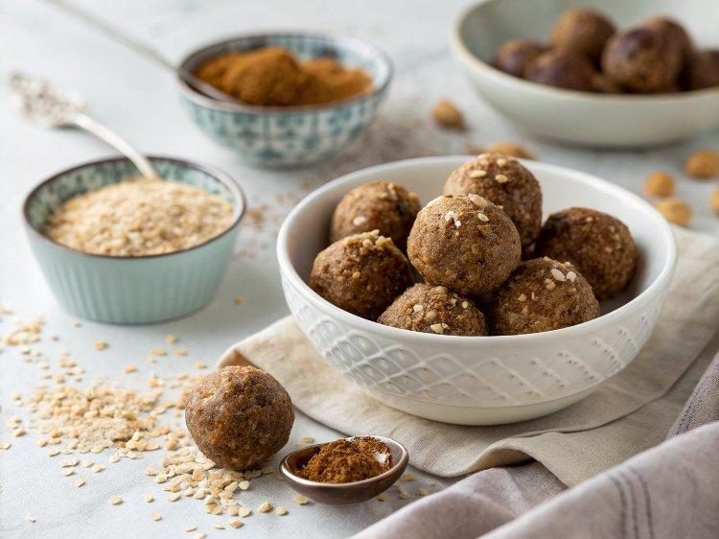

INGREDIENTS  - 1 cup (115 g) rolled oats or substitute quick oats  - 3 tbsp (18 g) ground flax meal, chia seeds, or hemp seeds  - 1/2 cup (135 g) nut butter or sunflower seed butter  - 1/3 cup (112 g) honey or pure maple syrup  - 1 tsp ground cinnamon  - 1/2 tsp ground cardamom, optional  - 1/4 tsp fine sea salt  - 1/4 cup (45 g) mini chocolate chips or substitute dried nuts and fruit | PREP  COOK  1. Stir all the ingredients together in a large bowl. The mixture will be a bit tricky to stir at first, but by pressing the nut butter and honey around and into the other ingredients, it will eventually become more cohesive.  2. If the mixture seems too dry and crumbly, add a bit more nut butter or honey. If the mixture seems too wet, sprinkle in some more oats.  3. Form into 1-inch (3cm) balls or for a slightly easier time forming the balls, place the mixture into the refrigerator for 20 to 30 minutes and then roll into balls.  4. When forming the balls, a medium cookie scoop is useful and helps to keep each ball the same size — we try to make the balls about 1-inch (3cm) in diameter, but this is up to you.  PLATING

