LEMONADE  COOK TIME: 5 min  SOURCE:  #refreshing #summer-drink #quick | 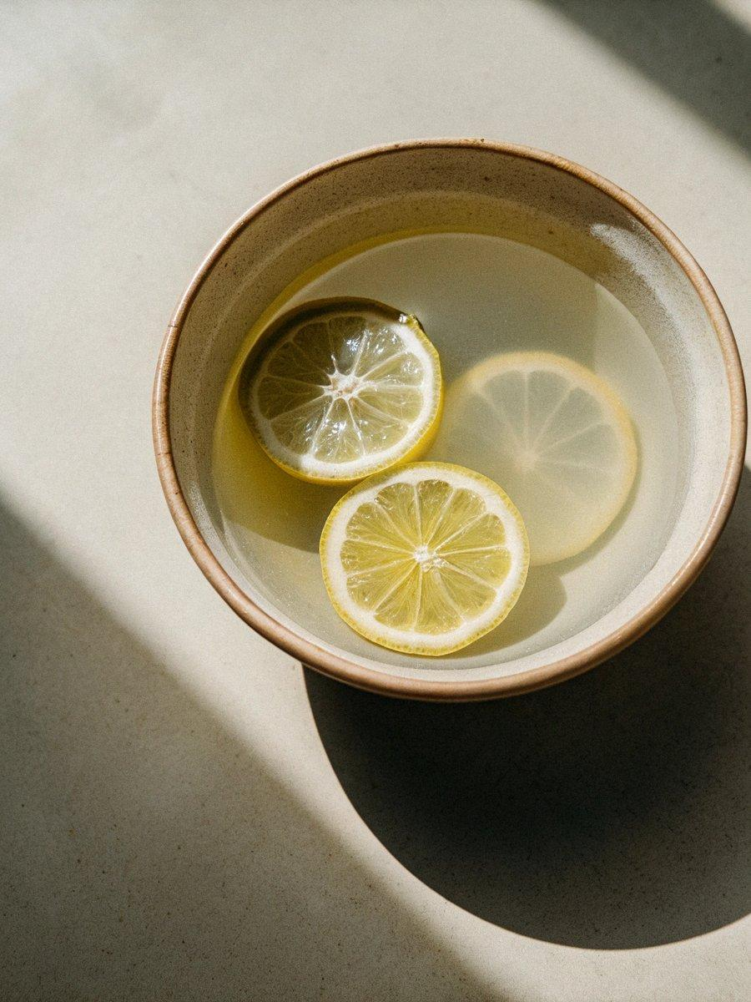

INGREDIENTS  - 1 cup (240ml) sugar  - 5 cups (1200ml) cold water, divided  - 1 cup (240ml) fresh lemon juice, from 6 to 8 lemons  - 1 lemon, thinly sliced | PREP  COOK  1. Make the Simple Syrup: Combine the sugar and 1 cup (240ml) of the water in a small saucepan. Bring to a simmer over medium heat and cook until the sugar is dissolved, 2 to 3 minutes. Set aside to cool.  2. Mix the Lemonade: In a glass pitcher, combine the lemon juice, the remaining 4 cups (960ml) of water, and the cooled simple syrup. Stir to combine. Add the lemon slices and chill until ready to serve. Serve over ice.  PLATING

