CUCUMBER WRAPPED SUSHI  COOK TIME: 45 min  SOURCE:  #sushi #fresh #seafood | 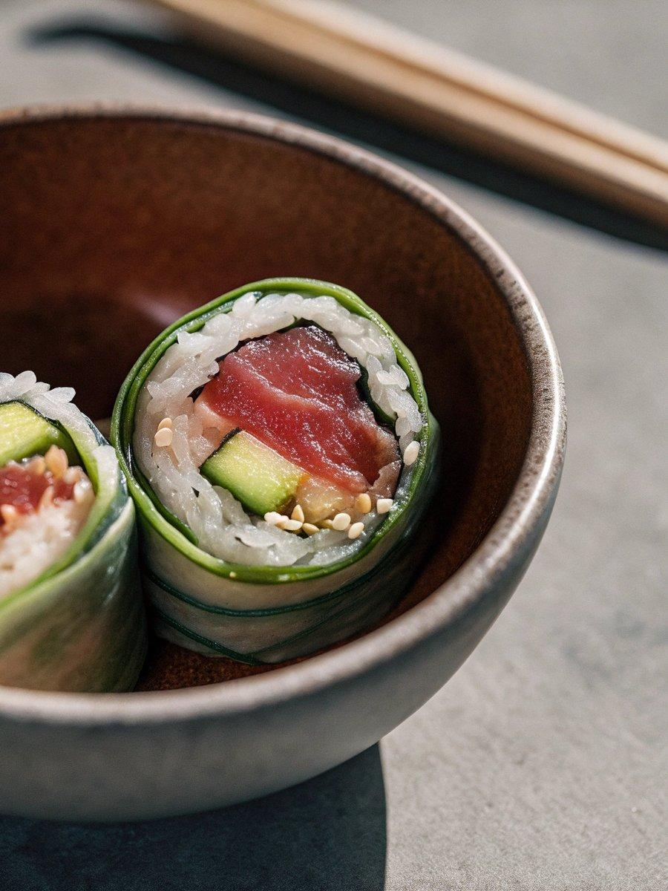

INGREDIENTS  - 2 Japanese or Persian cucumbers (or 1 English cucumber) 1  - 3–4 cups (960ml) sushi rice (cooked and seasoned) (see my recipe for How to Make Sushi Rice)  - 4 oz sashimi-grade tuna (maguro)  - 10 sashimi-grade shrimp (amaebi)  - 4 oz sashimi-grade salmon  - 4 oz sashimi-grade yellowtail (hamachi)  - 4 Tbsp ikura (salmon roe)  - 10 shiso leaves (perilla/ooba)  - 1 green onion/scallion (chopped)  - 1 lemon (sliced into small triangles)  - 1 bunch kaiware daikon radish sprouts | PREP  COOK  1. Gather all the ingredients. I also use a 1¾-inch (4.5-cm) round cookie cutter.  2. To Prepare the Fillings  3. Dice 4 oz sashimi-grade tuna (maguro) and lightly marinate the tuna with chopped green onion/scallion, soy sauce, and sesame oil.  4. Slice 2 Japanese or Persian cucumbers with a peeler to make long, thin strips.  5. To Assemble  6. Place 10 shiso leaves (perilla/ooba) on a serving platter. Dip a cookie cutter in a bowl of water (so the rice doesn‘t stick) and place it on top of a shiso leaf. With 3–4 cups (960ml) sushi rice (cooked and seasoned), stuff some sushi rice into the cookie cutter halfway up. Remove the cutter gently. Roll the sushi cylinder with one strip of cucumber to measure the circumference of the circle.  7. Make slits at the end of the cucumber strip with a knife as you see below. Now you can interlock the strips around the rice.  8. Fill the cucumber-wrapped sushi cups with your favorite toppings. For the 10 sashimi-grade shrimp (amaebi), I place a couple of pieces from the outer edges to the center of each cucumber cup, so it looks like a flower.  9. Slice 4 oz sashimi-grade salmon and 4 oz sashimi-grade yellowtail (hamachi) perpendicular to the muscle (the white line you see in the fish) and place a few slices in each cucumber cup.  1  0. Place the tuna mixture in some cucumber cups. Use 4 Tbsp ikura (salmon roe) to fill other cucumber cups. Place on a serving platter. Garnish the Cucumber Sushi as you like with 1 lemon, 1 green onion/scallion (chopped), and a few sprouts from 1 bunch kaiware daikon radish sprouts. Serve immediately.  1  1. To Store  1  2. I don‘t recommend keeping sashimi-grade fish and shrimp longer than 24 hours. Keep them refrigerated until serving.  PLATING

