CHOCOLATE SPIDER LAYER CAKE RECIPE  COOK TIME: 35 min  SOURCE:  #chocolate #cake #layered | 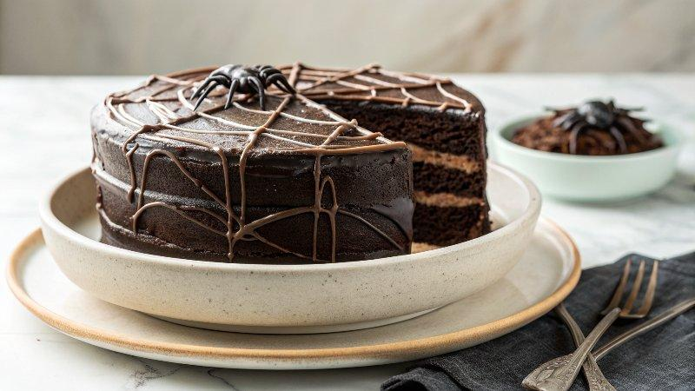

INGREDIENTS  - 2 cups (480ml) heavy cream  - 13 oz dark chocolate (chopped)  - 1 3/4 cups all-purpose flour  - 3/4 cup unsweetened cocoa powder  - 1 1/2 tsp baking powder  - 1 1/2 tsp baking soda  - 1 tsp salt  - 2 cup (480ml) granulated sugar  - 2 large eggs  - 1 cup (240ml) milk  - 1/2 cup neutral oil (vegetable oil)  - 2 tsp pure vanilla extract  - 1 cup (240ml) boiling water  - 16 chocolate pocky sticks  - 6 large white marshmallows  - Red and black fondant (for eyes)  - Chocolate sprinkles (for spider hair) | PREP  COOK  1. Chocolate Whipped Ganache  2. Heat the cream to a boil.  3. Pour over the chocolate in three parts, stirring each time until smooth.  4. Reserve ¼ cup of ganache for shaping the spider body later.  5. Cover the remaining ganache with plastic wrap (touching the surface) and refrigerate for at least 2 hours, until chilled.  6. Once chilled, whip using a stand mixer until light, fluffy, and firm.  7. Chocolate Cake  8. Preheat to 350°F (180°C) standard or 320°F (160°C) fan/convection. Lightly grease and line two 7-inch (18 cm) round cake pans with parchment paper.  9. In a large bowl, whisk together flour, cocoa powder, baking powder, baking soda, salt, and sugar until well combined.  1  0. Add the eggs, milk, oil, and vanilla, whisking until the batter is smooth and lump-free.  1  1. Slowly pour in the boiling water, whisking until the batter is silky and slightly thin — this makes it extra moist.  1  2. Divide batter evenly between pans and bake for 30–35 minutes, or until a toothpick inserted in the center comes out clean.  1  3. Let cakes cool in the pans for 10 minutes, then remove and transfer to a wire rack to cool completely before frosting.  1  4. Optional: pour ¼ cup of batter into a small greased mold for the spider body; bake for 40 minutes.  1  5. Once baked, run a knife around the edges and let the cake cool completely before removing from the pan.  1  6. Slice: the large cake horizontally into 2 layers and trim the top if domed.  1  7. Spread whipped ganache between the layers and over the entire cake. Chill to set the ganache.  1  8. Spider Web  1  9. Microwave marshmallows for 30 seconds until stretchy.  2  0. Pull strands apart with your fingers or two spoons and wrap them around the cake to form a web.  2  1. Spider Body  2  2. Crumble the small baked cake and mix with the reserved ganache.  2  3. Shape into a body and head, then roll in chocolate sprinkles.  2  4. Freeze briefly (10-15 minutes), then place on top of the cake.  2  5. Legs and Eyes  2  6. Insert 8 Pocky sticks for legs in an upside down V shape (4 per side).  2  7. Add red and black fondant eyes.  2  8. Keep refrigerated until ready to serve  PLATING

