EASY LAMB HOTPOT  COOK TIME: 1h 4m  SOURCE:  #comfort-food #hearty #one-pot | 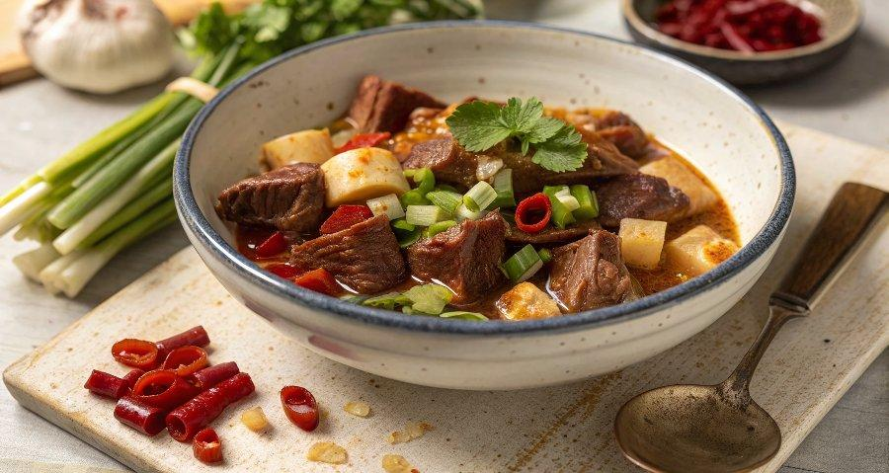

INGREDIENTS  - 1 x 280 g jar of artichoke hearts in oil  - 400 g higher-welfare lamb neck fillet  - 1 bunch of spring onions  - 1 heaped tbsp plain flour  - 1 bunch of mint (30 g)  - 400 g frozen peas  - 2 small baking potatoes (400 g total) | PREP  COOK  PLATING

