BOWTIES AND BROCCOLI  COOK TIME: 10 min  SOURCE:  #quick #comfort-food #pasta | 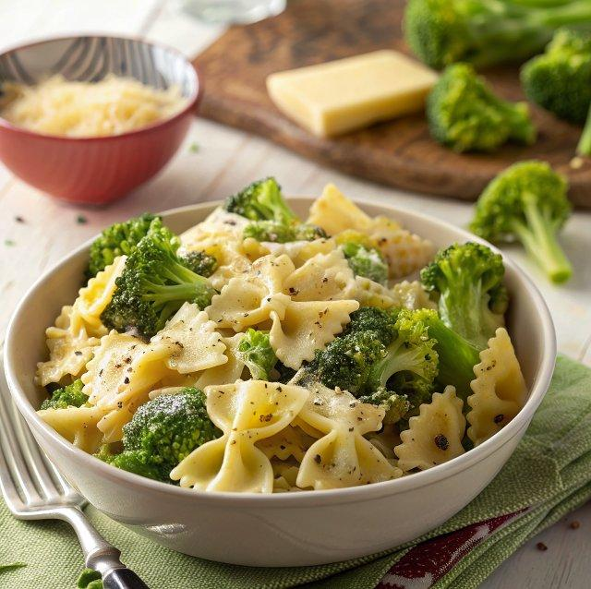

INGREDIENTS  - 12 oz. pasta ($1.00)  - 1 lb. frozen broccoli florets ($1.69)  - 3 Tbsp butter ($0.30)  - 3 Tbsp grated Parmesan ($0.31)  - Salt to taste ($0.05)  - Freshly cracked pepper to taste ($0.10)  - 1 pinch crushed red pepper (optional) ($0.05) | PREP  COOK  1. Bring a pot of water to a boil, then add the pasta. Boil until the pasta is al dente (7-10 minutes). Add the frozen broccoli florets to the boiling pasta water, turn off the heat, and let sit for 1-2 minutes, or until the broccoli is tender-crisp. Drain the pasta and broccoli in a colander.  2. Transfer the pasta and broccoli back to the pot (with the heat off) or to a bowl and add the butter. Toss until the butter has melted and coated everything. Add the Parmesan, salt, freshly cracked pepper, and red pepper flakes, then toss to coat again. Taste and adjust seasoning as needed. Serve immediately.  PLATING

