FONDANT POTATOES  COOK TIME: 40 min  SOURCE:  #comfort-food #potatoes #roasted | 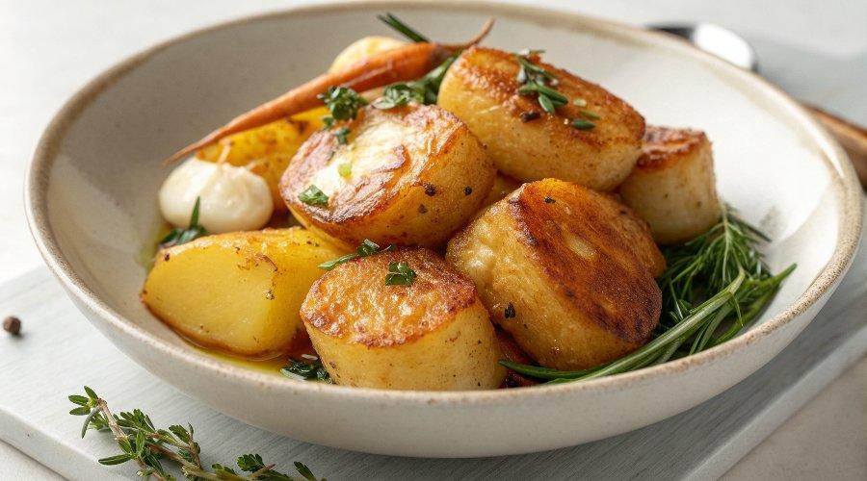

INGREDIENTS  - 6 medium Maris Piper potatoes  - 1 tbsp olive oil  - 200 g/7 oz unsalted butter cubed  - 4 large garlic cloves bashed  - 2 sprigs rosemary  - 2 sprigs thyme  - 200 ml/7 fl oz chicken or vegetable stock | PREP  COOK  1. Slice the ends off the potatoes so they lie flat on either side.  2. Heat the oil in a pan over a medium-low heat. When hot, add the potatoes cut-side down. Fry for 5-7 mins, or until deep golden brown, then flip and fry on the other side. Add the butter to the pan to melt.  3. Scatter the garlic and herbs around the potatoes and season well.  4. Carefully pour the stock around the veg, being aware of any hot butter that may splash out. Cover and simmer gently for 25-30 mins, or until the potatoes are tender, then serve.  PLATING

