VASILOPITA (GREEK NEW YEAR'S BREAD)  COOK TIME: 1h 45m  SOURCE:  #traditional #holiday #sweet | 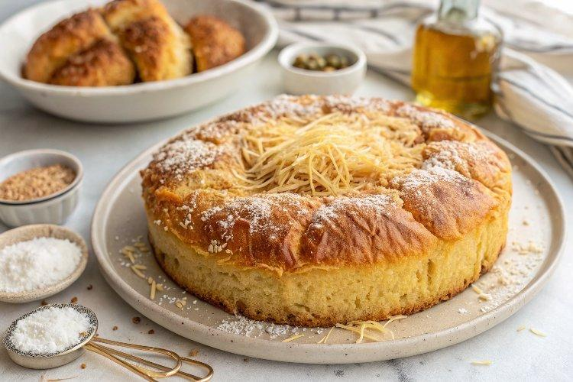

INGREDIENTS  - 2 1/2 cups granulated sugar  - 2 tbsp baking powder  - 1 cup (240ml) olive oil  - 3 cups (720ml) grated Romano cheese, (divided (optional, you can omit the cheese if you are looking for a sweeter bread)  - 1/2 tsp ground cinnamon  - 2 1/2 cups warm water  - 8 to 10 cups (2400ml) all-purpose flour, (plus more for dusting)  - 2 butter sticks, (melted)  - 1 egg yolk  - 3 tbsp sesame seeds  - 1/2 cup cinnamon  - 1 cup (240ml) sugar  - 1/4 tsp ground cloves  - 1/2 tsp allspice  - 1/2 tsp nutmeg | PREP  COOK  1. Add the sugar, baking powder, olive oil, 1 cup (240ml) of the grated cheese, and water to the large bowl of a stand mixer attached with a whisk. Whisk on low speed to combine.  2. Remove the whisk and add the hook attachment to the stand mixer.  3. Over medium-low speed, add the flour, one cup at a time. Knead for about 5 minutes or until you have a workable dough (it will be somewhat wet still).  4. Cover the dough with a towel and set aside for now.  5. Make the cinnamon mixture. In a medium mixing bowl, mix together the cinnamon, sugar, cloves, allspice, and nutmeg.  6. Prepare and lightly grease the bottom of a 10-inch (25cm) round springform pan.  7. Divide the dough into 11 equal size portions and form them into balls (you may need to flour your hands or a clean surface to help you shape the dough without sticking too much).  8. On a clean lightly floured surface, working with one ball of dough at a time, use a rolling pin and roll out the dough to a thin 10-inch (25cm) round. Place the first round of dough on the bottom of the prepared pan. Brush with the melted butter. Sprinkle generously with the cinnamon mixture and follow with a generous sprinkle of grated romano cheese.  9. Repeat with two more layers of dough. If you’re adding the coin for good luck, wash it well and dry it then wrap it in a piece of foil and place it on top of layer of dough you just laid down.  1  0. Continue shaping the dough balls into 10-inch (25cm) rounds and layering the dough rounds on top of each other in the pan, making sure to brush each layer with the melted butter and sprinkle with the cinnamon mixture and grated cheese until the very last layer.  1  1. Lay the last layer of dough on the very top. Combine the egg yolk with 2 tablespoons of water (or milk) and whisk. Brush the last layer of dough with a little melted butter and the egg wash. Finish with a sprinkle of the sesame seeds.  1  2. Heat the the oven to 350°F (175°C).  1  3. Bake on the middle rack for 1 hour and 45 minutes, until the vasilopita is a rich golden-brown. Allow it to cool for about 10 minutes before moving it from the baking pan to a wire rack. Allow to cool completely before slicing.  PLATING

