EGG DROP SOUP, THE CLASSIC VERSION (蛋花汤)  COOK TIME: 3 min  SOURCE:  #quick #comfort-food #healthy | 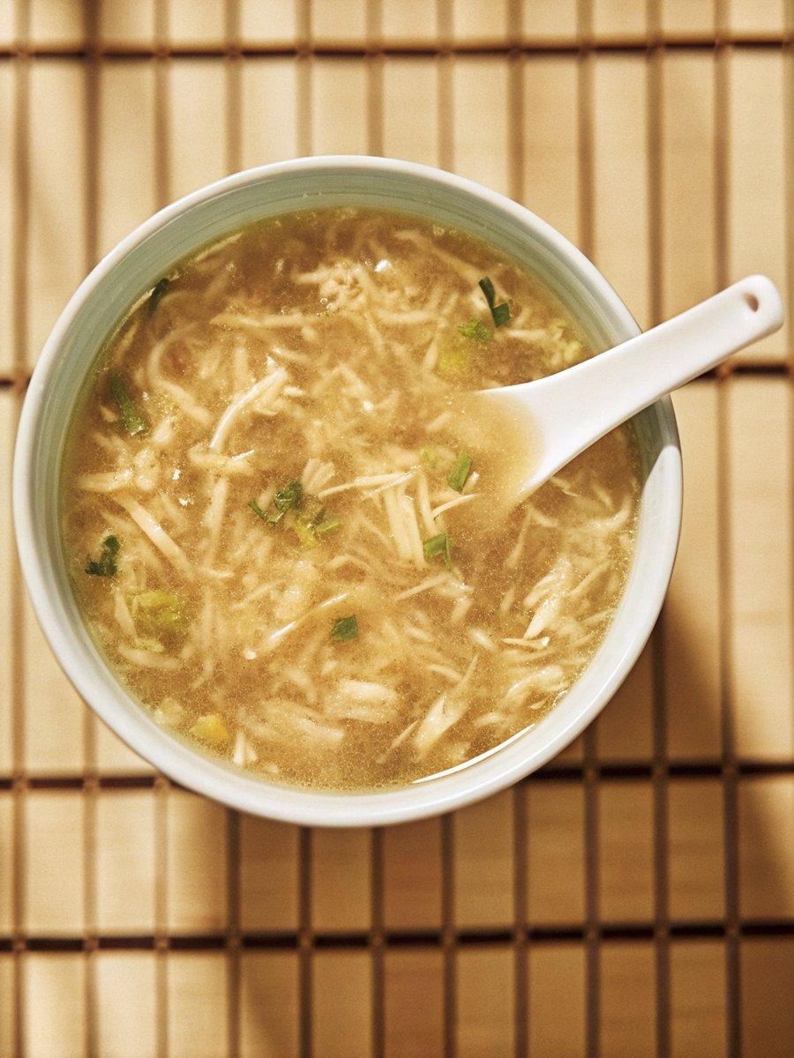

INGREDIENTS  - 3 large eggs  - 4 cups (960ml) chicken broth (or vegetable broth (see note 1)  - Salt (to taste)  - Ground white pepper (to taste)  - 1/4 tsp sesame oil  - 3 tbsp cornstarch  - 1 stalk scallions (finely chopped) | PREP  COOK  1. Crack the eggs then add 2 tablespoons of water. Beat lightly until the whites and yolks are fully integrated. Set aside.  2. Pour the broth into a saucepan/pot. Bring it to a full boil then turn the heat down to a gentle simmer.  3. Season the broth with salt, white pepper, and sesame oil. Taste to adjust.  4. In a small bowl, mix cornstarch with 6 tablespoons of water until combined (make sure no starch sinks to the bottom). Gradually pour it into the broth while stirring with a spoon.  5. Turn the heat to the lowest so the broth is at a bare simmer. Pour the beaten eggs in a thin stream while slowly swirling with the spoon.  6. Transfer the soup to individual bowls. Garnish with scallions and serve immediately.  PLATING

