WARM MEXICAN CORN SALAD (ELOTE)  COOK TIME: 5 min  SOURCE:  #quick #comfort-food #fresh | 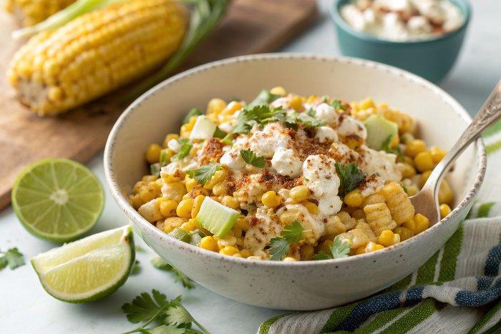

INGREDIENTS  - 4 large fresh cobs of corn  - 2 tbsp light mayonnaise  - 2 tbsp fat-free Greek yogurt  - 1/2 tsp chili powder (more or less to taste (check labels for GF)  - 1 tbsp fresh lime juice (from half a lime)  - 1 tbsp minced cilantro  - 2 tbsp scallions (minced)  - 1/2 cup 40 g cotija cheese, grated  - 5 lime wedges for serving | PREP  COOK  1. Boil corn in boiling water for 5 minutes, remove from heat.  2. When cool enough to handle, cut corn off the cobb. (makes 4 cups)  3. In a large bowl combine mayonnaise, yogurt, chili powder, and lime juice; mix well.  4. Add corn, cilantro, scallions and cheese and toss.  5. Serve with lime wedges.  PLATING

