JOWAR BAJRA GARLIC ROTI RECIPE  COOK TIME: 15 min  SOURCE:  #quick #healthy #comfort-food | 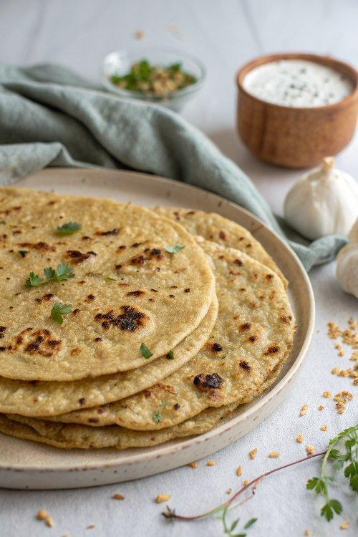

INGREDIENTS  - 1/2 cup Jowar Flour (Sorghum)  - 1/2 cup Bajra Flour ( Pearl Millet)  - 4 cloves Garlic finely chopped  - 2 tsp Black pepper powder  - Salt as per your taste  - Water for kneading the dough | PREP  COOK  1. To begin making Jowar Bajra Garlic Roti, in a bowl mix jowar flour and bajra flour.  2. Add garlic, pepper powder and salt to it. Mix all the ingredients well.  3. Add water little by little and knead into soft dough.  4. Divide into small balls and roll it flat with a rolling pin dusting some flour if required.  5. Heat a roti tawa and place the rolled out Jowar Bajra Garlic Roti.  6. Cook the Jowar Bajra Garlic Roti on a medium flame turning both the sides until brown spots appear. Take it off the griddle, add a teaspoon of ghee on top of the roti.  7. Finish the rest of the rotis and your Jowar Garlic Roti is ready to be served.  8. Serve Jowar Bajra Garlic Roti Recipe along with Mixed Vegetable Kurma for breakfast.  9. You can even serve the Jowar Bajra Garlic Roti for a Healthy lunch along with Horsegram Dal Recipe - Kulith/Kollu Dal and Raw Jackfruit & Peanut Masala Poriyal Recipe With Sambar Powder for a healthy Diabetic friendly meal.  PLATING

