CHICKEN AND VEGETABLE MEAL PREP  COOK TIME: 35 min  SOURCE:  #meal-prep #healthy #comfort-food | 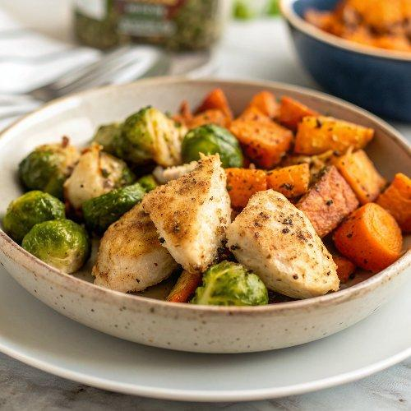

INGREDIENTS  - 1 lb. Brussels sprouts ($1.99)  - 1.25 lbs. sweet potato* ($1.25)  - 3 Tbsp cooking oil, divided ($0.12)  - 1/4 tsp salt ($0.02)  - 1/4 tsp pepper ($0.02)  - 1.3 lb. boneless, skinless chicken breast ($6.79)  - 2 tsp steak seasoning ($0.20)  - 1/2 tsp smoked paprika ($0.05)  - 1/2 tsp sweet paprika ($0.05)  - 1 Tbsp butter ($0.10) | PREP  COOK  1. Preheat the oven to 400ºF. Rinse the Brussels sprouts and slice them in half. Place them on a parchment-lined baking sheet, drizzle with 1 Tbsp oil, and add a pinch of salt and pepper. Toss to coat.  2. Wash the sweet potato then slice it in half lengthwise. Prick the outside surface with a fork. Rub 1 Tbsp oil over all surfaces of the sweet potato. Place the sweet potato, cut sides down, on the baking sheet with the Brussels sprouts.  3. Transfer the baking sheet to the oven and roast for 20 minutes. After 20 minutes, stir the Brussels sprouts, then return the baking sheet to the oven for 10-15 minutes, or until the Brussels sprouts have reached your desired level of browning. If the sweet potato is not softened all the way through at this point, just remove the sprouts and return the sweet potato to the oven.  4. While the vegetables are roasting, prepare the chicken breast. Combine the steak seasoning, smoked paprika, and sweet paprika in a bowl. Coat the chicken breasts in the seasoning mixture.  5. Heat the remaining tablespoon of oil in a large skillet over medium-low heat. Once hot, add the chicken breasts.  6. Cook the chicken breasts, without flipping, for about 8 minutes, or until well browned on the bottom. Flip the breasts and cook on the second side until well browned and cooked through (internal temperature 165ºF). Cooking time will vary with the thickness of the chicken.  7. Transfer the cooked chicken breast to a clean cutting board to rest for five minutes before slicing.  8. Cut the sweet potato halves in half once again to create four portions. Divide the sweet potatoes, Brussels sprouts, and sliced chicken between four containers. Add a pat of butter to each piece of sweet potato. Refrigerate up to four days.  PLATING

