CHORIZO SWEET POTATO SKILLET  COOK TIME: 45 min  SOURCE:  #comfort-food #one-pot #quick | 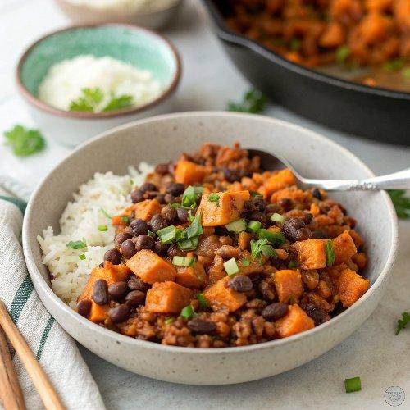

INGREDIENTS  - 1 Tbsp olive oil ($0.13)  - 1 sweet potato (1 lb.), $1.50)  - 1/2 lb. Mexican chorizo ($2.75)  - 1 15 oz. can black beans ($0.59)  - 1 cup (240ml) uncooked long grain white rice ($0.33)  - 1 cup (240ml) salsa (red or green), $0.46)  - 1.75 cup (18000ml) chicken broth ($0.23)  - 1 cup (240ml) shredded cheese ($0.90)  - 2-3 green onions (sliced, $0.20) | PREP  COOK  1. Peel and dice the sweet potato into 1/2 to 3/4-inch (10cm) cubes (size matters, make them small). Sauté the sweet potato cubes in a large skillet with olive oil over medium heat for about 5 minutes, or until the sweet potatoes have softened about half way through (they'll cook more later).  2. Add the chorizo to the skillet (squeeze it out of its casing if it came in links) with the sweet potatoes. Sauté the chorizo and sweet potatoes together, breaking the chorizo up into small pieces as it browns.  3. Once the chorizo is fully browned, pour off any excess grease if needed. Rinse and drain the black beans. Add the beans, salsa, and uncooked rice to the skillet. Stir them into the sweet potatoes and chorizo until everything is well combined.  4. Add the chicken broth, stir briefly, then place a lid on the skillet. Allow the contents of the skillet to come up to a boil, then turn the heat down to low. Let the skillet simmer on low for 30 minutes. Make sure it is simmering the whole time (you should be able to hear it quietly simmer away). If it is not, turn the heat up slightly.  5. After 30 minutes the rice should be tender and have absorbed all of the liquid. Turn off the heat, fluff the mixture, sprinkle the cheese on top, then return the lid to trap the residual heat and help the cheese melt. Slice the green onions while the cheese is melting, then sprinkle them on top and serve.  PLATING

