HOW TO MAKE OAT MILK  COOK TIME: 5 min  SOURCE:  #dairy-free #quick #healthy | 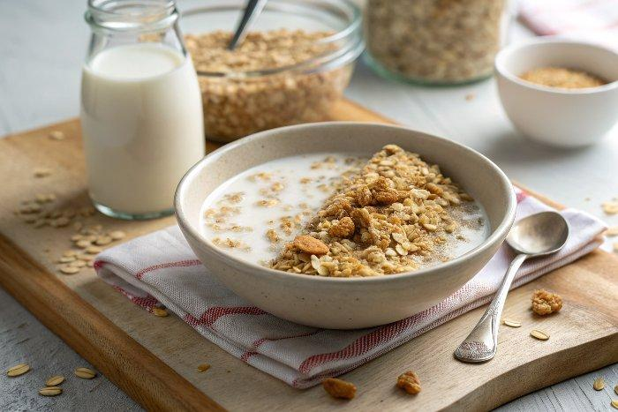

INGREDIENTS  - 1/2 cup whole rolled oats  - 3 cups (720ml) water  - 2 tsp maple syrup  - 1/2 tsp vanilla extract  - 1/8 tsp sea salt | PREP  COOK  1. Combine the oats, water, maple syrup, vanilla, and salt in a blender and blend for 30 seconds.  2. Place a fine mesh strainer over a large bowl and strain the milk without pushing any excess pulp through the strainer. This will create a creamier texture that’s not gritty or gummy.  3. Add more maple syrup, to taste, if desired. Chill overnight. If you want to drink your oat milk right away, I recommend adding ice - it's flavor is best when well chilled.  PLATING

