CHIPOTLE LOBSTER AVOCADO WRAP  COOK TIME: 15 min  SOURCE:  #seafood #wrap #healthy | 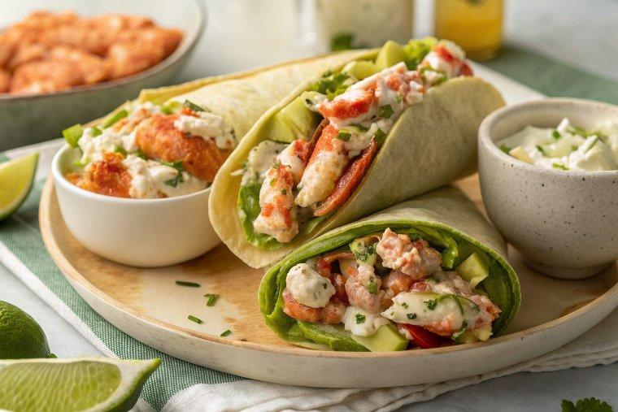

INGREDIENTS  - 9 oz about 1 3/4 cups steamed lobster meat, chopped (from 2 lb lobster)  - 3 tbsp Hellmann's light mayo  - 2 tbsp 2% fat Greek yogurt  - 1 tbsp chipotle paste or chopped peppers in adobo sauce  - 1 green onions (finely chopped)  - 1 tbsp fresh lemon juice  - 1 tbsp minced cilantro  - 1 medium avocado (diced)  - 8 medium romaine lettuce leaves  - 4 whole wheat (low carb tortillas (8 inches), room temperature (or sub for GF tortillas) | PREP  COOK  1. Chop the lobster meat into small pieces.  2. In a medium bowl combine the light mayonnaise, yogurt, chipotle pepper, green onion and cilantro.  3. Add the lobster, squeeze the lemon juice over the lobster and mix well.  4. Place 2 lettuce leaves over each wrap, top with about 1/3 cup of the lobster salad and 1/4 of the avocado.  5. Wrap by folding the edges in slightly and slice diagonally.  PLATING

