BAESUK (HONEY POACHED PEARS) - KOREAN ROYAL COURT CUISINE STYLE  COOK TIME: 20 min  SOURCE:  #sweet #comfort-food #quick | 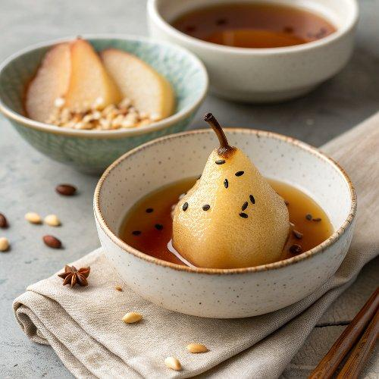

INGREDIENTS  - 1 Korean pear (490 g / 1 lb), peeled)  - 3 cups (720ml) water  - 15 g ginger (0.5 oz), peeled, thinly sliced)  - 2 Tbsp sugar (or honey)  - 24 black peppercorns (optional)  - Some pine nuts (optional) to garnish) | PREP  COOK  1. Put the sliced ginger into a pot and add the water. Boil over medium high heat until rolling boiling (7 to 8 mins).  2. (At the same time as step 1) Cut the pears into wedge shapes (about 8 pieces). Push through the black peppercorns on the back of the pears (typically 3 peppercorns per slice). You may want to use a chopstick or an equivalent tool to push them deep, so that they don’t fall out. Though, if you don’t like this additional peppercorn flavour, it can be omitted.  3. Discard the ginger from step  1. Add the sliced pears and sugar / honey into the pot. Boil them over low heat for about 10 mins.  4. Remove the pot from the heat and cool down. Chill in the fridge for a few hours. Garnish the drink with some pine nuts before serving. Serve cold or warm.  PLATING

