TWICE COOKED PORK (HUI GUO ROU, 回锅肉)  COOK TIME: 35 min  SOURCE:  #comfort-food #stir-fry #pork | 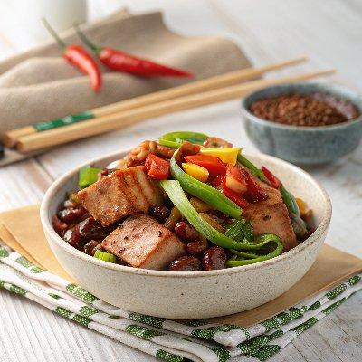

INGREDIENTS  - 300 g pork belly, in one piece (10 oz)  - 5 slices ginger  - 2 tsp cooking oil  - 1 tbsp Sichuan chilli bean paste (see note 1)  - 1 tbsp fermented black beans (Dou Chi, 豆豉) (see note 2)  - 3 cloves garlic, sliced  - 1 small leek, cut diagonally (see note 3)  - 2 fresh red chili peppers, cut diagonally  - 1 tsp light soy sauce  - 1 tsp Shaoxing rice wine  - 1 pinch sugar | PREP  COOK  1. Precook the pork  2. boil  3. Place pork belly and ginger into a pan. Pour in enough water to cover the meat. Bring the water to a full boil. Turn down the heat and leave to simmer for 30 mins (see note 4).  4. slice  5. Drain the pork then put it into a bowl of cold water. Once it’s cool enough to touch, cut it crosswise into thin slices. Pat dry the pork slices with paper towel to remove any excess water on the surface (this helps to prevent oil splashing in the next step).  6. Stir-fry the dish  7. heat  8. Heat the wok over high heat until it starts to smoke (See note 5 if you’re using a non-stick wok). Pour in oil and add pork belly pieces.  9. sear  1  0. Stir constantly to sear the meat. Once it lightly browns, transfer to a plate but leave all the oil in the wok.  1  1. sizzle  1  2. Turn the heat to low. Add Sichuan chili bean paste, fermented black beans and garlic to the oil. Sizzle for 30 seconds or so.  1  3. fry  1  4. Turn up the heat to high. Put the pork slices back into the wok. Add leek, fresh chili, Shaoxing rice wine, soy sauce and sugar. Stir fry until the leek and chili start to wilt (but still a little crunchy). Dish out and serve immediately.  PLATING

