THE ULTIMATE BURGER  COOK TIME: 35 min  SOURCE:  #comfort-food #grilled #quick | 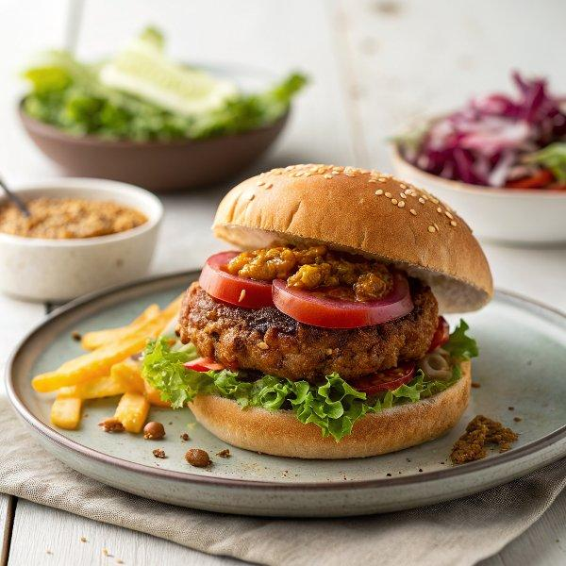

INGREDIENTS  - 4 gherkins  - 2 ripe tomatoes  - 200 g red cabbage  - red wine vinegar  - 1/2 an iceberg lettuce  - 1/2 a cucumber  - extra virgin olive oil  - 1 x 400 g tin of green lentils  - 250 g higher-welfare minced beef or veggie mince  - olive oil  - 4 slices of Cheddar cheese (60 g total)  - 4 small burger buns  - optional: tomato ketchup and/or mayo | PREP  COOK  1. Slice the gherkins (use a crinkle-cut knife, if you’ve got one) and tomatoes, and set aside. Finely slice or grate the red cabbage, then toss in a mixing bowl with 1 tablespoon of red wine vinegar.  2. Shred the lettuce and slice the cucumber, then place in another mixing bowl and dress with 1 tablespoon of extra virgin olive oil.  3. Drain the lentils and pat dry with kitchen paper, then blitz in a food processor with the mince and a pinch of black pepper. Divide the mixture into 4 equal pieces and shape into 3cm (1-inch)-thick patties.  4. Place a large non-stick frying pan on a medium heat. Brush the patties with 1 tablespoon of olive oil, then carefully place in the hot pan and cook for 4 minutes on each side, or until just cooked through, nudging the patties towards the edge of the pan to sear the sides.  5. When the burgers are looking good, place a slice of cheese on top of each one, add a splash of water to the pan (the steam will help the cheese to melt), then cover for an extra 4 minutes, or until melted.  6. Cut the buns in half (toast them if you like), add a dollop of ketchup and/or mayo (if using) to each base, then place a burger on top.  7. Layer the gherkin, tomato and cucumber slices, and a pinch of lettuce on top of each one, then pop the lids on. Serve the rest of the lettuce, cucumber and tomato on the side, along with the pickled cabbage.  PLATING

