FRIED WONTONS  COOK TIME: 20 min  SOURCE:  #fried #savory #appetizer | 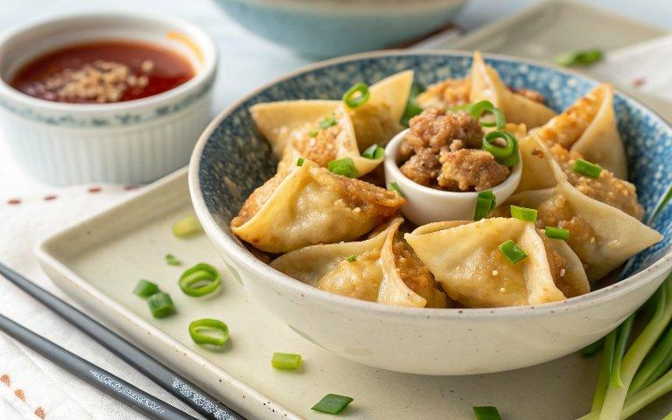

INGREDIENTS  - 12 oz. ground pork (340 g)  - 2 tbsp finely chopped scallions  - 1 tsp sesame oil  - 1 tbsp soy sauce  - 1 tbsp shaoxing wine (or dry sherry)  - 1/2 tsp sugar  - 1 tbsp peanut or canola oil  - 2 tbsp water (plus more for sealing the wontons)  - 1/8 tsp white pepper  - 40-50 Wonton skins (1 pack, medium thickness)  - 2 tbsp apricot jam  - 1/2 tsp soy sauce  - 1/2 tsp rice wine vinegar  - 2 tbsp honey  - 2 tbsp Sriracha  - 1 1/2 tbsp light soy sauce  - 1 tbsp sugar (dissolved in 1 tbsp hot water)  - 1 tsp Worcestershire sauce  - 1/2 tsp toasted sesame seeds (optional) | PREP  COOK  1. Start by making the filling. Simply combine the ground pork, chopped scallions, sesame oil, soy sauce, wine (or sherry), sugar, oil, water, and white pepper in a bowl. Whip everything together by hand for 5 minutes or in a food processor for 1 minute. You want the pork to look a bit like a paste.  2. To make the wontons, take a wrapper, and add about a teaspoon of filling. Overstuffed wontons will pop open during the cooking process and make a mess. Use your finger to coat the edges with a little water (this helps the two sides seal together).  3. For shape #1:  4. Fold the wrapper in half into a rectangle, and press the two sides together so you get a firm seal. Hold the bottom two corners of the little rectangle you just made, and bring the two corners together, pressing firmly to seal. (Use a little water to make sure it sticks.)  5. Shape #2:  6. Fold the wonton in half so you have a triangle shape. Bring together the two outer corners, and press to seal (you can use a little water to make sure it sticks).  7. Keep assembling until all the filling is gone (this recipe should make between 40 and 50 wontons). Place the wontons on a baking sheet or plate lined with parchment paper to prevent sticking.  8. At this point, you can cover the wontons with plastic wrap, put the baking sheet/plate into the freezer, and transfer them to Ziploc bags once they’re frozen. They’ll keep for a couple months in the freezer and be ready for the fryer whenever you’re ready.  9. To conserve oil, use a small pot to fry the wontons. Fill it with 2 to 3-inch (8cm) of oil, making sure the pot is deep enough so the oil does not overflow when adding the wontons. Heat the oil to 350 degrees, and fry in small batches, turning the wontons occasionally until they are golden brown.  1  0. If you have a small spider strainer or slotted spoon, you can use it to keep the wontons submerged when frying. This method will give you the most uniform golden brown look without the fuss of turning them. Remove the fried wontons to a sheet pan lined with paper towels or a metal cooling rack to drain.  1  1. To make one or all of the sauces, simply mix the respective ingredients in a small bowl, and you’re ready to eat!  PLATING

