CARROT GINGER DRESSING  COOK TIME: 10 min  SOURCE:  #quick #healthy #dressing | 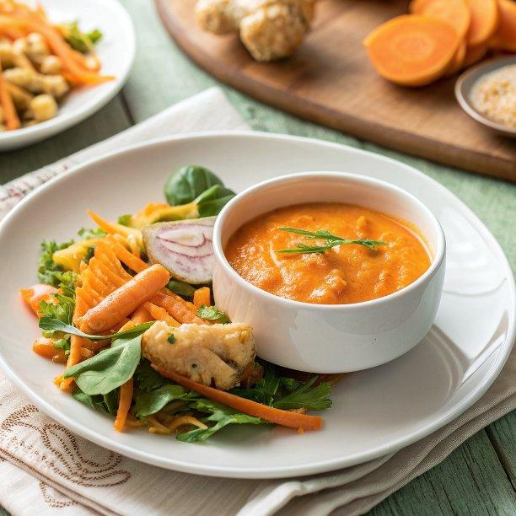

INGREDIENTS  - 1 carrot (4.8 oz, 135 g) 4.8 135  - 1/4 onion (2.5 oz, 70 g) 2.5 70  - 1 knob ginger (1 inch, 2.5 cm; 0.6 oz, 17 g; preferably milder young/spring ginger) 1 2.5 0.6 17  - 1 1/2 Tbsp sugar  - 1 Tbsp miso (I use mild and mellow white miso)  - 1/4 tsp Diamond Crystal kosher salt (to taste)  - freshly ground black pepper (to taste)  - 1 tsp toasted sesame oil  - 1/2 cup rice vinegar (unseasoned) (DO NOT substitute other vinegars as they are too acidic and strong)  - 1/4 cup neutral oil | PREP  COOK  1. Gather all the ingredients.  2. To Prep the Vegetables  3. Peel 1 carrot and chop it into pieces about ½–1 inch (1.25–2.5 cm).  4. Chop ¼ onion into 1-inch (2.5-cm) pieces.  5. Peel 1 knob ginger and slice into small pieces. Put all the chopped vegetables into a food processor (I use my 3-cup Cuisinart Blender Food Processor Duo) or a high-powered home blender like Vitamix.  6. To Blend the Dressing  7. Purée until fine and smooth.  8. Add 1½ Tbsp sugar, 1 Tbsp miso, ¼ tsp Diamond Crystal kosher salt, and freshly ground black pepper to the vegetable purée.  9. Add 1 tsp toasted sesame oil, ½ cup rice vinegar (unseasoned), and ¼ cup neutral oil.  1  0. Process again until the dressing is completely smooth. Taste and adjust the seasoning with salt, as needed. If it‘s too sour, add a bit more sugar. If you prefer a lighter dressing, add water to thin it; I don‘t add water so the dressing will keep longer.  1  1. To Serve  1  2. Serve over a green salad. Here, I have a salad of iceberg lettuce, cucumber, red radishes, and tomatoes.  1  3. To Store  1  4. You can store the dressing in an airtight container or mason jar for up to 1 week. Shake well before using. If you take out the portion you need and put the dressing back into the refrigerator right away, it will keep for up to 2 weeks. Or, you can store it in the freezer for up to a month.  PLATING

