GEORGIAN-INSPIRED LEG OF LAMB  COOK TIME: 1h 10m  SOURCE:  #roasted #comfort-food #herb-infused | 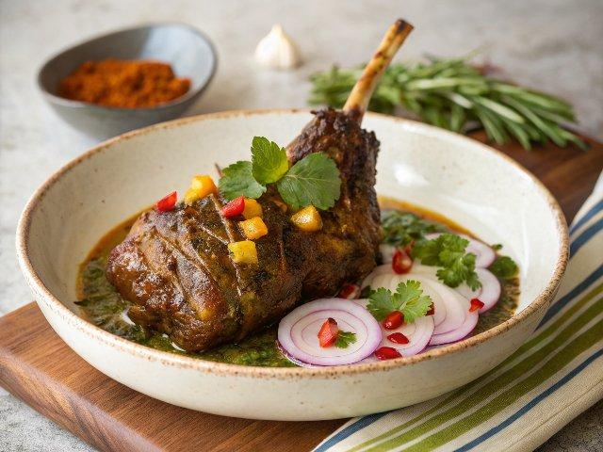

INGREDIENTS  - 4 onions  - 3 tsp blue fenugreek  - 3 tsp dried marigold powder  - 2 tsp chilli powder  - 2 tsp ground coriander  - 1 tbsp fresh marigold flowers  - a few sprigs of fresh rosemary  - 4 cloves of garlic  - 1 lemon  - 1 pomegranate  - olive oil  - 1 x 2.8 kg higher-welfare leg of lamb, butterflied (ask your butcher to do this for you)  - 1 bunch of fresh tarragon (20 g)  - 1 bunch of fresh mint (30 g)  - cold-pressed sunflower oil  - red wine vinegar | PREP  COOK  1. First, light your barbecue. Let the coals burn down to a medium heat, then lift the cooking grill, carefully insert the whole, unpeeled onions among the coals and leave them to cook for 50 minutes to 1 hour, or until charred and tender. Remove and allow them to cool.  2. Meanwhile, pound the blue fenugreek, dried marigold, chilli powder and coriander in a pestle and mortar with a generous pinch of sea salt and 2 teaspoons of black pepper. Pick in the marigold petals and rosemary leaves, peel and add 2 garlic cloves, and pound again. Squeeze in the lemon juice and half the pomegranate juice, add 3 tablespoons of olive oil and muddle together to make a rustic paste.  3. Lay the lamb out like an open book. Using a small sharp knife, make little incisions into the meat, then rub the marinade all over, making sure you really get it into all those little nooks and crannies. Sprinkle with a good pinch of salt and pepper.  4. Place the lamb on the barbecue and cook for 40 minutes to 1 hour, turning every 10 minutes – bear in mind that the cooking time will vary depending on the thickness of your lamb. To check that it’s cooked, you could use a meat thermometer – you need the lamb to reach an internal temperature of 55ºC. Transfer to a platter and rest for 15 minutes, or until the internal temperature reaches 60ºC.  5. Peel the charred onions and squeeze them out of their skins, then roughly chop the soft flesh on a large chopping board. Tear over the tarragon and mint leaves, roughly chop it all together, then season with sea salt and drizzle over 3 tablespoons of sunflower oil. Peel and grate over the remaining clove of garlic, add 2 tablespoons of vinegar, sprinkle over the pomegranate seeds and spread the mix across the board to create a base for your lamb.  6. Move the lamb to the board, then slice it up and tuck in. Delicious served with my Georgian-inspired red rice (see below).  PLATING

