STRAWBERRY KALE SALAD WITH NUTTY GRANOLA CROUTONS  COOK TIME: 20 min  SOURCE:  #healthy #fresh #quick | 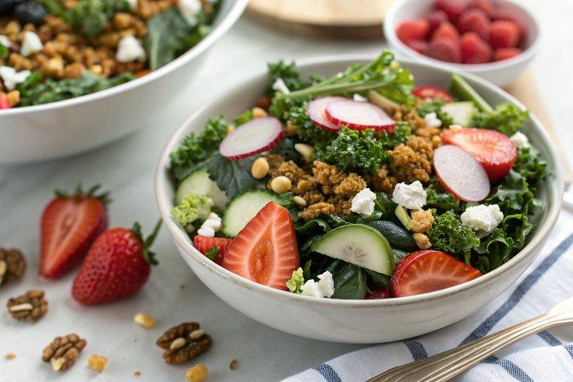

INGREDIENTS  - 8 oz Tuscan kale or regular curly kale (one medium bunch)  - 1/2 lb strawberries, hulled and sliced  - 4 to 5 medium radishes, sliced thin and roughly chopped  - 2 oz chilled goat cheese (or about 1/3 cup goat cheese crumbles), more if you’d like  - 3 tbsp olive oil  - 2 tbsp lemon juice (about 1 small lemon)  - 1 tbsp smooth Dijon mustard  - 1 1/2 tsp honey  - 1/8 tsp fine salt  - Freshly ground pepper, to taste  - 1 cup (240ml) old-fashioned oats  - 1/2 cup raw shelled pistachios (or chopped walnuts or pecans)  - 1/2 cup whole almonds  - 1/2 cup raw sunflower seeds  - 1/4 cup raw sesame seeds  - 1/2 tsp fine salt  - 1/4 tsp cayenne pepper  - 1 large egg white, beaten (optional, see note for vegans)  - 1/4 cup olive oil  - 1 tbsp honey or maple syrup | PREP  COOK  1. To make the granola: Preheat oven to 350°F (175°C). In a medium bowl, toss the oats, pistachios, almonds, sunflower seeds, sesame seeds, salt, and cayenne pepper. Stir in the beaten egg white, oil, and honey until well blended. Transfer mixture to a rimmed baking sheet and bake, stirring halfway, until golden, about 16-19 minutes. Let the granola cool on the baking sheet.  2. To make the dressing: In a small bowl, whisk together the olive oil, lemon juice, mustard, honey and salt until well blended. Season generously with freshly ground black pepper, to taste.  3. To prepare the kale: Use a chef’s knife to remove the tough ribs from the kale, then discard the ribs (or feed them to your dog!). Chop the kale leaves into small, bite-sized pieces. Transfer the chopped kale to a big salad bowl. Sprinkle a pinch of salt over the kale and massage the leaves with your hands by lightly scrunching big handfuls at a time, until the leaves are darker in color and fragrant.  4. To assemble the salad: Drizzle in the salad dressing (you might not need all of it) and toss well, until all of the kale is lightly coated in dressing. Add the sliced strawberries and chopped radishes, then use a fork to crumble the goat cheese over the salad. For the best flavor, let the salad rest for 15 minutes before serving (this gives the dressing time to soak into the kale).  5. Top with granola just before serving to preserve its crunch (if you intend to have leftovers, add granola to individual servings and store it separately from the salad). This salad will keep well covered in the refrigerator for up to 2 days and the granola will keep in an air-tight freezer bag in the freezer for several months. It’s good on salads or yogurt.  PLATING

