CHINESE FIVE SPICE CHICKEN (五香烤鸡)  COOK TIME: 45 min  SOURCE:  #roasted #comfort-food #spicy | 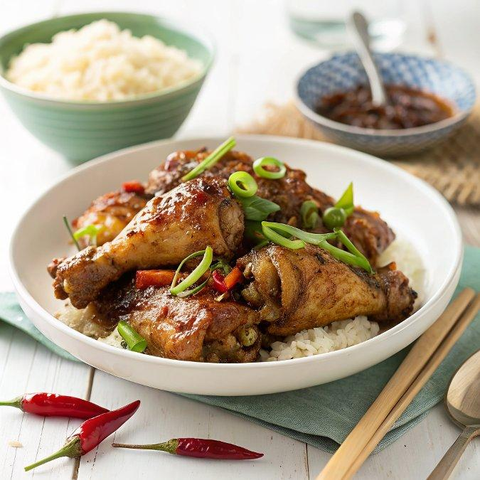

INGREDIENTS  - 1 free range chicken (about 1.8 kg/4 lbs )  - 2 tsp salt  - 3/4 tsp five spice powder  - 1/4 tsp garlic powder/garlic granule  - 1/4 tsp ground white pepper  - 1 tsp dark soy sauce  - 1 tsp Shaoxing rice wine (optional)  - 1 tbsp honey  - 1/2 tsp dark soy sauce | PREP  COOK  1. Spatchcock  2. Place the chicken over a large tray with the breasts down and the legs towards you. Find its backbone in the middle. Use kitchen scissors/shears to cut along both sides of the backbone, separating it from the ribs (see images for reference in the post above).  3. Flip over the chicken so that the breasts are facing up. Use the palm of your hand to firmly push the middle of the chicken until it’s completely flattened.  4. Season  5. Pat dry the whole chicken with kitchen paper to remove any moisture.  6. Mix salt, five spice powder, garlic powder and white pepper in a bowl. Rub half of the mixture over the cavity side.  7. Flip over the chicken. Mix dark soy sauce and Shaoxing rice wine. Rub it over the skin side. Then spread the rest of the dry mix. Massage to evenly distribute.  8. Leave to rest uncovered in the fridge overnight (12-24 hours).  9. Roast  1  0. One hour before cooking, take the chicken out of the fridge and allow it to come back to room temperature.  1  1. Preheat a fan-assisted oven at 390F°/200C°, or 425F°/220C° if using a conventional oven.  1  2. Use a roasting tray with a wire rack that fits inside. Fill the tray with some water (lower than the rack) and put the chicken on the rack (skin facing up). Place the tray in the middle of the oven. Leave to cook for 15 minutes.  1  3. Turn the oven down to 320F°/160C° (or 350F°/180C° if using a conventional oven). Continue cooking for a further 20 minutes. If your chicken is a little bigger or smaller, increase or reduce the time by 5 minutes or so (Check the water level in the tray and top up if necessary).  1  4. Take out the chicken. Mix honey and soy sauce then brush a thin layer over the skin. Put back into the oven. Cook for another 5 minutes.  1  5. Turn the heat back up to 390F°/200C° (or 425F°/220C° for a conventional oven). Take out the chicken and brush a second time. Roast for 5 more minutes to finish.  1  6. Rest  1  7. Check the doneness (see footnote to learn how). Then take the chicken out and leave to rest for 10 minutes before carving into small pieces to serve.  PLATING

