BRAISED ITALIAN SAUSAGES WITH RED WINE, PORCINI MUSHROOMS & CREAMY POLENTA  COOK TIME: 1h 30m  SOURCE:  #comfort-food #hearty #slow-cooked | 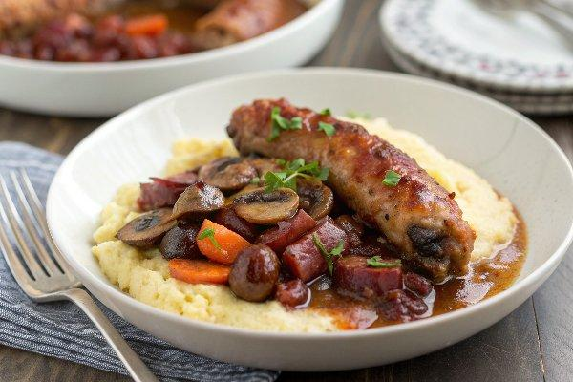

INGREDIENTS  - 25 g dried porcini mushrooms  - 2 tbsp olive oil  - 8 Italian pork sausages  - 200 g portobellini mushrooms sliced  - 1 onion finely chopped  - 1 carrot finely chopped  - 2 celery sticks finely chopped  - 3 garlic cloves thinly sliced  - 400 g can plum tomatoes  - 2 rosemary sprigs leaves picked and finely chopped  - 2 fresh bay leaves  - 200 ml chianti  - 1 tsp sugar  - steamed greens, peas and chopped parsley, to serve (optional)  - 375 g quick-cook polenta  - 1.4 L milk  - 80 g parmesan finely grated  - 80 g butter  - 50 ml double cream | PREP  COOK  1. Tip the dried porcini into a heatproof bowl and cover with 150ml boiling water. Set aside. Heat half the oil in a large, shallow flameproof casserole dish over a medium heat and fry the sausages for 3 mins on each side, or until golden brown. Remove to a plate.  2. Heat the rest of the oil in the pan over a medium-high heat and fry the mushrooms for 5-7 mins until they have released most of their liquid. Stir in the veg and garlic, and fry for 5 mins. Add the rehydrated porcini, the tomatoes, herbs, wine and sugar, bring to a simmer and cook for 10 mins. Add the sausages, cover, reduce the heat and cook for 1 hr.  3. Cook the polenta with the milk following pack instructions, then stir in the cheese, butter and cream. Season to taste. Serve the polenta with the sausages alongside some steamed greens, peas and a sprinkling of parsley, if you like.  PLATING

