RAGI KANJI RECIPE - SALT VERSION  COOK TIME: 20 min  SOURCE:  #healthy #comfort-food #quick | 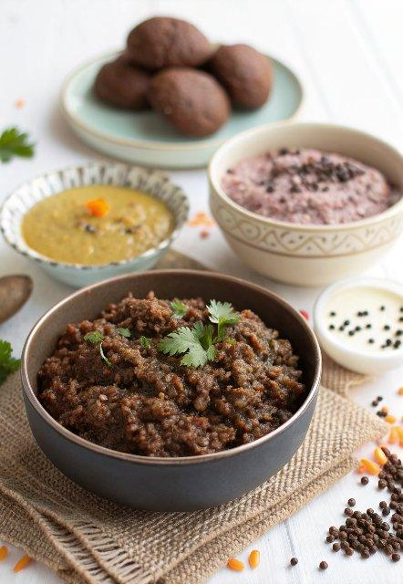

INGREDIENTS  - 2-1/2 cups Water  - 3 tbsp Ragi Flour (Finger Millet/ Nagli)  - 1 tsp Cumin seeds (Jeera)  - 1/2 tsp Ajwain (Carom seeds)  - 1/4 tsp Asafoetida (hing)  - Salt to taste  - 1/4 cup Curd (Dahi / Yogurt)  - 1/4 tsp Cumin powder (Jeera) | PREP  COOK  1. To begin making the Ragi Kanji, first heat 2 cups (480ml) of water in a saucepan.  2. Add the Ragi flour to the remaining 1/2 cup of water along with the cumin seeds, ajwain, hing and salt. Stir well to dissolve it completely till no lumps remain.  3. Once the water starts boiling, slowly add the ragi-water mixture, stirring constantly to ensure that there are no lumps. Cook and stir for 1-2 minutes. After the ragi porridge is cooked add the curd into the ragi porridge and stir continuously. Simmer for about three minutes and turn off the heat.  4. Transfer the Ragi Kanji into a serving bowl and serve hot with a dollop of Ghee. Sprinkle some cumin powder if you like.  5. Serve Ragi Kanji to your family members for a healthy breakfast or a midday snack.  PLATING

