2-INGREDIENT STRAWBERRY POPSICLES + LINKS TO INSPIRE.  COOK TIME: 4h 5m  SOURCE:  #quick #refreshing #healthy | 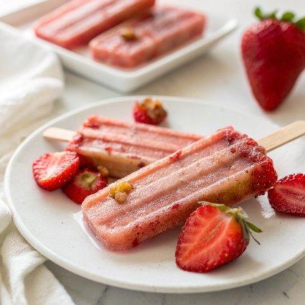

INGREDIENTS  - 2 cups (480ml) Strawberry Coconut Juice * (16 oz, I used Strawberry Apple Coconut)  - 1 lb fresh strawberries (cored and roughly chopped) | PREP  COOK  1. Spray two popsicles molds lightly with olive oil spray.  2. Add the strawberry apple coconut juice and strawberries to a blender. Blend until mostly smooth or completely smooth if you do not want any chunks of strawberries.  3. Pour the mixture among the molds. You will only fill up 2-4 popsicles on the second mold.  4. Place the molds in the freezer and freeze until firm, about 4 hours. To remove the popsicles run the mold under hot water for 10 seconds and then pull the popsicles out of the molds.  PLATING

