SAUSAGE, BROCCOLI & CHILLI PASTA  COOK TIME: 15 min  SOURCE:  #quick #comfort-food #pasta | 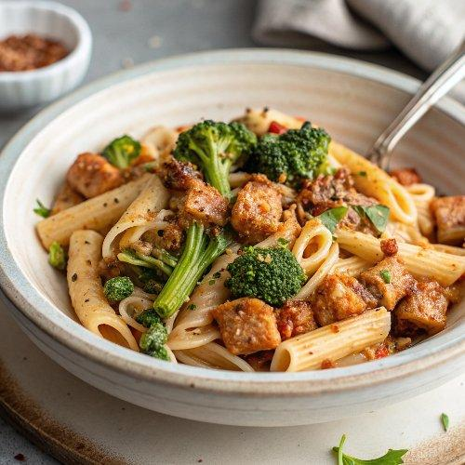

INGREDIENTS  - 300 g rigatoni  - 330 g long-stemmed broccoli any larger stems trimmed or halved  - 6 pork sausages sausagemeat squeezed from its skins  - 1 tbsp olive oil  - 1 tsp chilli flakes  - 2 garlic cloves crushed  - 2 tbsp parsley leaves picked and finely chopped, stems finely chopped  - 3 tbsp crème fraîche  - 1/2 lemon zested and juiced  - 1 red chilli deseeded and finely sliced | PREP  COOK  1. Cook the rigatoni in a pan of boiling salted water following pack instructions, adding the broccoli for the last 3-4 mins until just tender. Drain, reserving a mugful of the cooking water.  2. Meanwhile, put the sausagemeat and oil in a cold frying pan and cook over a medium heat, stirring often for 6-8 mins until the fat starts to render and the meat is golden and crisp. Remove to a bowl using a slotted spoon.  3. Stir in the chilli flakes, garlic and parsley stems, and cook for 2-3 mins more until fragrant. Stir through the lemon zest, return the sausagemeat to the pan, then toss in the drained pasta and broccoli. Stir in the crème fraîche, lemon juice and splash of the reserved pasta cooking water, and cook for another minute until everything comes together. Serve in bowls topped with the red chilli slices.  PLATING

