EASY APPLE CRISP  COOK TIME: 35 min  SOURCE:  #quick #comfort-food #baking | 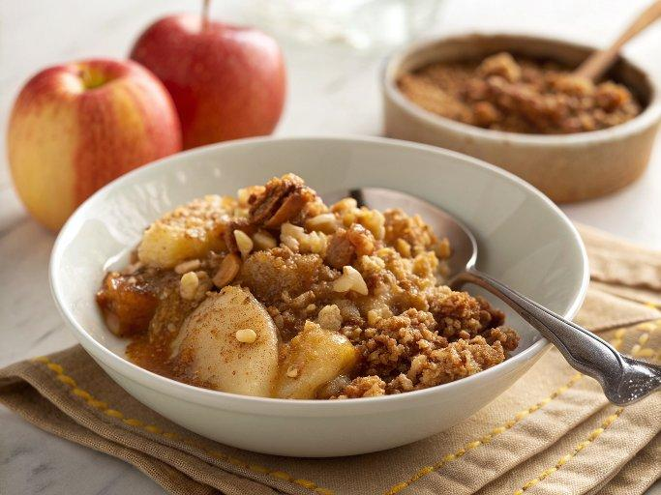

INGREDIENTS  - 1 cup (240ml) old-fashioned oats (use certified gluten-free oats if making this recipe GF)  - 1/2 cup almond meal*  - 1/2 cup chopped pecans or walnuts  - 1 1/2 tsp ground cinnamon, divided  - 1/4 tsp salt  - 1/4 cup maple syrup  - 1/4 cup melted butter (or coconut oil, if making this recipe vegan)  - 4 apples, cored and diced (about 5-6 cups)  - 2 tsp freshly-squeezed lemon juice | PREP  COOK  1. Preheat oven to 350°F (175°C).  2. Add oats, almond meal, nuts, 1/2 teaspoon cinnamon, and salt to a mixing bowl, and toss until combined. Add maple syrup and melted butter (or coconut oil), then toss until combined. Set aside.  3. In a separate bowl, combine the apples, lemon juice and remaining 1 teaspoon cinnamon, and toss until combined. Spread the apple mixture evenly into a greased 8×8-inch (20cm) or 9×9-inch (23cm) pan, then sprinkle the oat mixture evenly on top of the apples.  4. Bake for 35-40 minutes, or until the topping is crisp and golden and the apples are soft and cooked through. Serve immediately. (I served mine with ice cream and a drizzle of caramel sauce.)  5. Or let the apple crisp cool to room temperature, then cover and refrigerate for up to 3 days.  PLATING

