MASALA FISH  COOK TIME: 50 min  SOURCE:  #spicy #comfort-food #seafood | 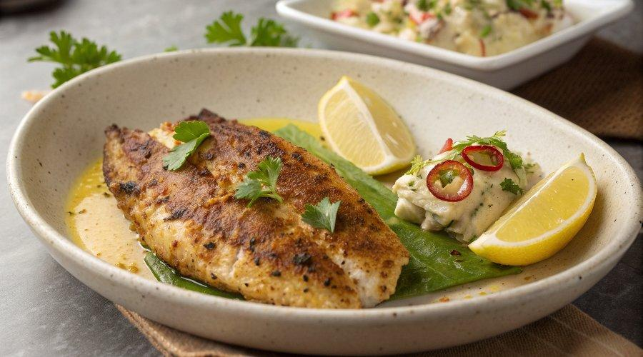

INGREDIENTS  - 600 g firm, sustainably caught white fish fillets (about 4 large fillets)  - 300ml (1.2 cups) vegetable oil  - 2 garlic cloves grated  - 2 tbsp vegetable oil  - 1/4 lemon juiced, plus extra wedges to serve  - 1 tsp tandoori masala powder  - 90 g chickpea (g) flour  - 30 g rice flour  - 1 tsp hot paprika  - 1 tsp ground turmeric  - 1/2 tsp cumin seeds crushed  - 1/2 tsp coriander seeds crushed  - 1 green chilli deseeded and finely chopped (optional)  - 1 kg white baking potatoes  - 3 tbsp olive oil  - 300 g frozen peas  - 60 g feta or use natural yogurt  - 1/4 lemon juiced  - 1 garlic clove grated  - 10 mint leaves finely chopped  - 1/2 tsp red chilli flakes (optional) | PREP  COOK  1. For the chips, scrub or peel the potatoes, then cut into 1.5cm (2-inch)-thick chips. Cover with cold salted water, then bring to the boil. Boil for 4-5 mins, then drain well. Tip out onto a clean tea towel and pat dry.  2. Arrange the chips on a baking tray lined with baking parchment, drizzle over the olive oil and season well. Bake at 220C/200C fan/gas 7 for 35 mins, turning halfway through, until golden brown all over.  3. Meanwhile, snip each fillet of fish into two pieces lengthways (this makes it easier to cook evenly). Whisk the marinade ingredients together with ¼ salt in a small bowl. Brush this over both sides of the fish fillets. Keep chilled until ready to fry.  4. To make the batter, whisk all the ingredients together with ¼ salt in a large bowl. Gradually add 175ml cold water, whisking continuously, until you have a smooth batter that is the consistency of thick pouring cream. Leave to stand for a few minutes while you make the peas.  5. Cook the peas in a pan of boiling water for 2 mins until just tender. Drain well and transfer to a bowl. Add the rest of the ingredients and blitz using a hand blender, or crush well using a fork or potato masher – the texture should be fairly coarse.  6. Heat the vegetable oil in a deep frying pan to 180C (when you drop in a little batter, it should float to the top) – it should be about 2cm (1-inch) deep. Coat each fish fillet in the batter, then carefully transfer to the hot oil. Fry for about 3 mins before gently turning and frying for a further 2-3 mins. You can fry a couple of fillets at a time, but do not overcrowd the pan. Drain the fried fish on kitchen paper and repeat until all the fillets are cooked. Serve the fish, chips and peas with lemon wedges to squeeze over and your favourite condiments on the side.  PLATING

