FRIED APPLES RECIPE  COOK TIME: 15 min  SOURCE:  #quick #comfort-food #sweet | 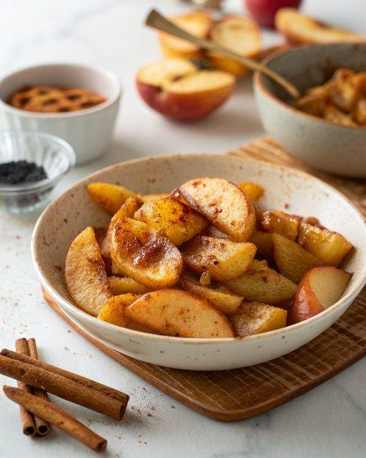

INGREDIENTS  - 6 tbsp salted butter (85 g)  - 1/4 cup granulated sugar (50 g)  - 1/4 cup light brown sugar (50 g)  - 2 1/2 tsp ground cinnamon  - 1/4 tsp nutmeg  - 4 large Granny Smith apples (peeled, cored, and sliced) | PREP  COOK  1. In a large cast-iron skillet, melt the butter over medium heat. Add the sugars, cinnamon and nutmeg, stirring until sugar is moistened. Cook until the mixture is boiling, about 2 minutes.  2. Add the apples and stir to coat.  3. Cook, stirring frequently, until the apples are cooked to desired tenderness, 6 to 10 minutes for crisp-tender and about 15 minutes for very soft apples. Serve immediately.  PLATING

