SPINACH QUICHE  COOK TIME: 1h 20m  SOURCE:  #comfort-food #quick #savory | 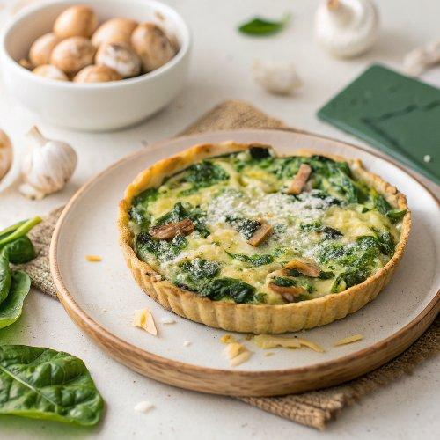

INGREDIENTS  - 1 unbaked flaky pie crust (what I use) or all-butter pie crust*  - 10 oz (283 g) frozen spinach*  - 2 tsp olive oil  - 8 oz (227 g) sliced mushrooms  - 2 garlic cloves, minced  - 4 large eggs  - 1 cup (240 ml) whole milk*  - 1/3 cup (25 g) freshly grated or shredded parmesan cheese  - 1 cup (4 oz/113 g) freshly shredded cheddar cheese*  - 1/4 tsp each salt and pepper | PREP  COOK  1. Prepare pie crust  2. I like to make sure my pie dough is prepared before I begin the quiche. Make pie dough the night before because it needs to chill in the refrigerator for at least 2 hours before rolling out and par-baking.  3. Roll out the chilled pie dough  4. On a floured work surface, roll out one of the discs of chilled dough (save the second pie crust for another recipe). Turn the dough about a quarter turn after every few rolls until you have a circle 12-inch (30cm)es (30cm) in diameter. Carefully place the dough into a 9-inch (23cm) pie dish. Tuck it in with your fingers, making sure it is completely smooth. To make a lovely edge, I do not trim excess dough around the edges. Instead, fold the excess dough back over the edge and use your hands to mold the edge into a rim around the pie. Crimp the pie crust edges with a fork or use your fingers to flute the edges. Chill the pie crust in the refrigerator for at least 30 minutes and up to 5 days. Cover the pie crust with plastic wrap if chilling for longer than 30 minutes.  5. Preheat oven to 375°F (190°C).  6. Par-bake  7. Line the chilled pie crust with parchment paper. Fill with 2 packs of pie weights, or use dried beans. Make sure the weights are evenly distributed around the pie dish. Bake until the edges of the crust are starting to brown, about 15–16 minutes. Remove from the oven and carefully lift the parchment paper (with the weights) out of the pie. Prick holes all over the bottom crust with a fork. Return the pie crust to the oven. Bake until the bottom crust is just beginning to brown, about 7–8 minutes. Remove from the oven and set aside. (Crust can still be warm when you pour in the filling, or you can par-bake the crust up to 3 days ahead of time. Cover cooled par-baked crust tightly and refrigerate until ready to fill.)  8. Reduce oven temperature to 350°F (177°C).  9. For the filling  1  0. If your frozen spinach is not already thawed, thaw it in the microwave per package directions. Drain the spinach in a colander while you prepare the rest of the ingredients.  1  1. In a large skillet, heat the oil over medium-high heat. Add the sliced mushrooms, garlic, and a sprinkle of salt and pepper to hot skillet (just a sprinkle of each, you’ll use 1/4 teaspoon each in the next step). Stir and sauté the mushrooms until they release all of their moisture and no more water remains on the bottom of the skillet, about 6–7 minutes.  1  2. Whisk the eggs, milk, parmesan cheese, and 1/4 teaspoon each salt and pepper together until combined.  1  3. Blot and squeeze the rest of the water out of the thawed spinach. Spread spinach on par-baked pie crust. Add the cooked mushrooms and shredded cheese. Pour the egg mixture on top. If desired, sprinkle the top with a little more parmesan cheese.  1  4. Bake the quiche until the center is just about set, about 50–60 minutes. Don’t over-bake. Use a pie crust shield to prevent the pie crust edges from over-browning. Cool for 15 minutes before slicing and serving. Or you can cool the quiche completely before serving—it’s fantastic at room temperature, too.  1  5. This quiche makes great leftovers! Cover tightly and store in the refrigerator for up to 4 days.  PLATING

