EASY CHOW MEI FUN  COOK TIME: 6 min  SOURCE:  #quick #comfort-food #noodles | 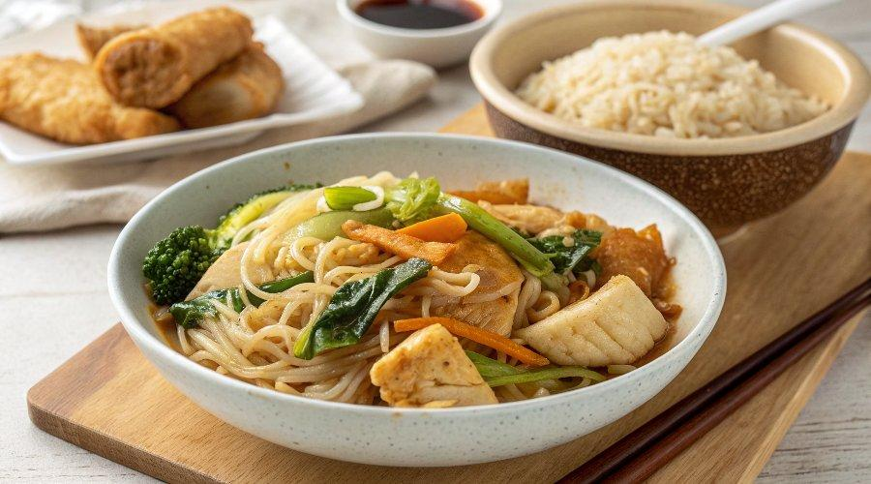

INGREDIENTS  - 1 piece chicken breast  - 1/2 tbsp cornstarch (or tapioca, potato starch)  - 1 pinch salt  - 1 tbsp Shaoxing rice wine  - 1 tsp neutral cooking oil  - 3 1/2 oz dried mei fun (aka rice vermicelli/thin rice noodles)  - 1 tbsp light soy sauce  - 1/2 tbsp dark soy sauce  - 1/2 tbsp oyster sauce  - 1/4 tsp ground white pepper  - 1/2 tsp sesame oil  - 2 tbsp neutral cooking oil (divided)  - 3 stalk scallions (cut diagonally, white and green parts separated)  - 3 cloves garlic (minced)  - 1/2 bell pepper (julienned)  - 3 1/2 oz fresh mushrooms (shiitake, oyster, or button mushrooms, sliced)  - 3 1/2 oz bean sprouts | PREP  COOK  1. Marinate the chicken  2. Cut chicken breast into bite-sized, thin slices. Put them into a bowl. Add cornstarch, salt, and Shaoxing rice wine. Mix and rub until there is no more liquid to be seen. Add 1 teaspoon of cooking oil and stir to coat the chicken pieces evenly.  3. Prepare the noodles  4. Put dried mei fun into a large bowl. Pour in just boiled water to fully submerge the noodles. Let sit for 2 minutes. Drain well then cut the noodles into shorter, more manageable sections.  5. Mix the seasoning  6. Add light soy sauce, dark soy sauce, oyster sauce, white pepper, and sesame oil to a small bowl. Mix well then set aside.  7. Sear the chicken  8. Heat a wok/deep skillet until very hot. Add 1 tablespoon of cooking oil (If using non-stick cookware, you need to add the oil first then start heating the wok/skillet). Swirl to coat a larger area of the wok. Put in the chicken slices and arrange them in a single layer.  9. Once the bottom side browns slightly, flip and toss to sear further. As soon as the chicken no longer looks pink, transfer it out to a plate (do not overcook).  1  0. Combine the dish  1  1. Add the remaining 1 tablespoon of cooking oil to the vacant wok. Sizzle the white part of the scallions and minced garlic until fragrant (do not burn).  1  2. Put in the noodles then use chopsticks to loosen them. Add bell pepper, mushrooms, and bean sprouts. Stir and toss constantly to evenly cook everything.  1  3. Once the mushrooms begin to wilt, put the chicken back into the wok, along with the seasoning mixture and the green part of the scallions. Give everything a final stir to well distribute the sauce. Dish out and serve immediately.  PLATING

