SPICY ROASTED SALMON RECIPE  COOK TIME: 15 min  SOURCE:  #quick #healthy #grilled | 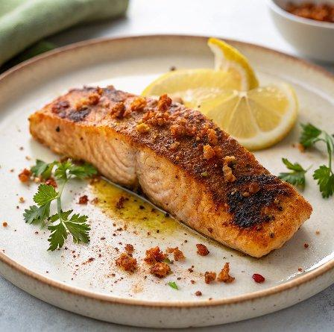

INGREDIENTS  - 3 Fish fillet salmon  - Oil as required for frying  - 2 tbsp Oil  - 1 tsp Red Chilli powder adjust according to your spice level  - 1/2 tsp Black pepper powder  - 1 tsp Ginger Garlic Paste  - 1/4 tsp Turmeric powder (Haldi)  - 2 tsp Lemon juice  - Salt to taste | PREP  COOK  1. To begin making the Spicy Roasted Salmon recipe, place the fillets, skin-side down in the heated pan and cook for about 2 minutes on each side for thinner fillets and an additional minute for thicker fillets, until they are browned and flaky. Salmon leaves so much oil, hence if you use  2. Salmon leaves so much oil, hence if you use a non-stick pan, oil is not needed for pan frying.  3. Wash and clean salmon fillets In a bowl, mix all the ingredients to form a thick paste.  4. If the paste is too thick, add few drops of lemon juice more. Coat the salmon fillet with marinade and let it stand for about 10 minutes  5. Heat a non-stick pan over medium heat. If the fillets stick at the bottom, just add drops of cooking oil.  6. Salmon cooks faster. Ensure not to overcook as it becomes rubbery.  7. Serve Spicy Roasted Salmon Recipe along with Roasted Baby Potato Recipe or with sauteed mushrooms and spinach for a complete healthy protein packed dinner.  PLATING

