EASY STRAWBERRY CAKE WITH STRAWBERRY SAUCE  COOK TIME: 50 min  SOURCE:  #quick #comfort-food #baking | 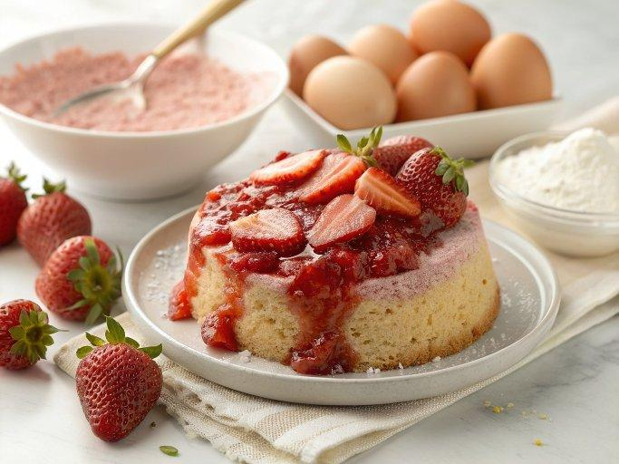

INGREDIENTS  - 2 large eggs (room temperature)  - 1 cup (240ml) granulated sugar  - 1 cup (240ml) sour cream  - 1/2 cup light olive oil ( or vegetable oil)  - 1 tsp vanilla extract  - 2 cups (480ml) all-purpose flour (*measured correctly)  - 2 tsp baking powder  - 1/4 tsp salt  - 12 oz strawberries (hulled)  - 1 tsp powdered sugar (for dusting, optional)  - 16 oz strawberries (hulled and halved)  - 1/4 cup granulated sugar (or to taste) | PREP  COOK  1. Cake Prep:  2. Butter a 9" springform pan and line the bottom with parchment paper. Preheat oven to 375˚F. Prepare 12 oz of strawberries for the cake: dice 6 oz of strawberries and slice the second 6 oz into halves.  3. How to Make Strawberry Cake:  4. In a large mixing bowl, using an electric hand mixer (or stand mixer), beat together 2 eggs with 1 cup (240ml) sugar on high speed for 5 minutes or until light in color and thick.  5. Add 1 cup (240ml) sour cream, 1/2 cup oil, 1 tsp vanilla and beat on low speed until well combined.  6. In a small bowl, whisk together: 2 cups (480ml) flour, 2 tsp baking powder and 1/4 tsp salt until well incorporated. With the mixer on med/low speed, add flour mixture to the batter 1/3 at a time, letting the flour incorporate with each addition and continue mixing just until well combined. Do not over-mix.  7. Pour half of the batter into prepared pan. Top with 6 oz of diced strawberries then spread remaining batter over the top. Cover the surface with 6 oz of halved strawberries (cut-side-down), pressing them down just slightly into the batter. Bake at 375˚F for 45-55 minutes (mine was perfect at 50 min), or until a toothpick inserted into center comes out clean. Let cake rest in pan 15-20 min before removing the ring.  8. Run a thin spatula around cake edges to loosen from pan. then transfer to a cake platter. Cool until just warm or at room temperature. To serve, dust with powdered sugar if desired. Drizzle individual slices generously with strawberry syrup.  9. How to Make Strawberry Sauce:  1  0. While the cake is baking, make the strawberry sauce: In a blender or food processor, combine 16 oz strawberries and 1/4 cup sugar (or add sugar to taste) and blend until pureed.  PLATING

