VEGAN BAKED ZITI  COOK TIME: 17 min  SOURCE:  #comfort-food #pasta #baked | 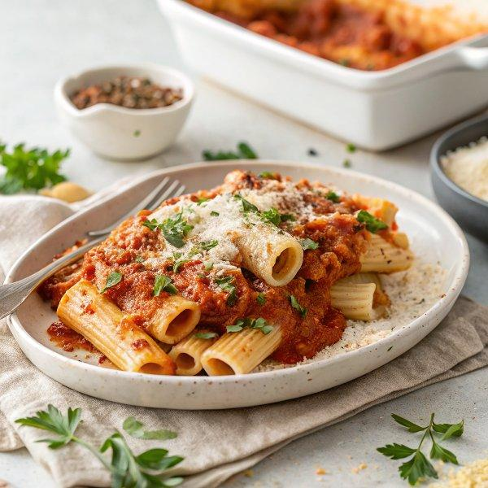

INGREDIENTS  - 9 oz Ziti noodles (or similar shape (e.g. Rigatoni, Penne)  - 20 oz marinara sauce  - 3 cloves of garlic  - 1 tsp oregano  - 1 tsp onion powder  - 1 tsp paprika  - 1/4 tsp smoked paprika  - 1 pinch of cayenne pepper (optional)  - 1 batch vegan cheese sauce (or store-bought vegan cheese)  - 1 (15 oz) can mushrooms (or use fresh)  - 1/2 tbsp oil (or use water if oil-free)  - 1 tbsp balsamic vinegar  - 1 tbsp soy sauce  - Fresh herbs (to garnish) | PREP  COOK  1. Cook the pasta according to the instructions on the packaging but reduce the cooking time by about one minute. The pasta should be al dente and not mushy!  2. Preheat oven to 375°F (190°C)ahrenheit (190 degrees Celsius).  3. Chop mushrooms and mince the garlic cloves.  4. Heat oil (or water) in a skillet over medium heat, add mushrooms, soy sauce, and balsamic vinegar. Sauté for about 3-5 minutes.  5. In a medium-sized bowl or saucepan combine marinara sauce, minced garlic, oregano, onion powder, paprika, smoked paprika, a pinch of cayenne pepper (optional), salt, and pepper. Stir with a whisk or a spoon to combine.  6. Pour some sauce into the casserole dish (mine measures 9"x6" resp. 23x15 cm but you can also use a 8x8 pan) and add cooked pasta.  7. Top with mushrooms, add the remaining marinara sauce and stir to combine.  8. Make a batch of my vegan cheese sauce and pour it on top. You can, of course, also use store-bought vegan cheese of choice!  9. Bake in the oven for about 10-15 minutes. You can use a broiler for the last 3-4 minutes if you like. Enjoy!  PLATING

