BIRCHER MUESLI (CHILLED SWISS OATMEAL)  COOK TIME: 8h 5m  SOURCE:  #healthy #quick #no-cook | 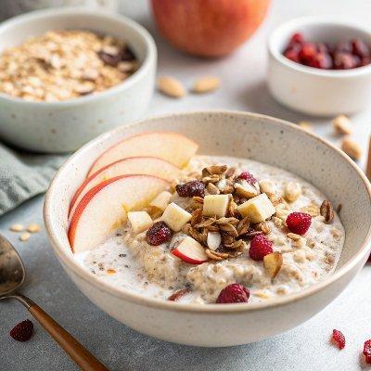

INGREDIENTS  - 1 cup (240ml) old fashioned rolled oats  - 1/2 cup unsweetened almond milk (or any non-dairy milk of choice )  - 1/2 cup plain Greek yogurt (or dairy-free yogurt if needed )  - 2 tbsp dried cranberries  - 1/2 cored Pink Lady apple (chopped into small pieces)  - 1/2 a ripe banana (chopped into small pieces)  - 1/2 tsp vanilla  - sprinkle of cinnamon  - 1 tbsp roasted almonds (chopped, for topping)  - chia seeds (for topping)  - maple syrup (for drizzling) | PREP  COOK  1. Combine  2. Add oats, milk, yogurt, cranberries, apple, banana, vanilla and cinnamon to a medium-sized bowl and stir to combine.  3. Soak  4. Cover and place in the refrigerator to soak overnight.  5. Serve  6. In the morning, add a splash or two of almond milk, if desired and stir the mixture. Portion out a serving and sprinkle almonds, chia seeds and a drizzle of maple syrup over the top. Enjoy!  PLATING

