STEAK SANDWICH  COOK TIME: 30 min  SOURCE:  #sandwich #grilled #comfort-food | 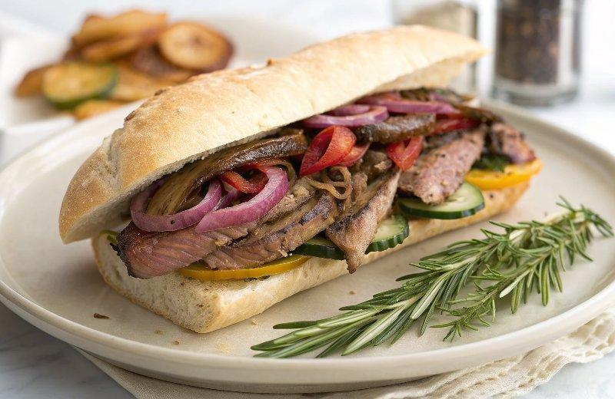

INGREDIENTS  - 1 ciabatta loaf  - olive oil  - 2 red capsicums  - 2 red onions  - 2 small green zucchini  - 2 small yellow zucchini  - 1/2 a bunch of fresh rosemary (15 g)  - 350 g higher-welfare sirloin steak  - balsamic vinegar  - 1 handful of fresh basil leaves  - 1 x 150 g ball of buffalo mozzarella  - 8 tbsp green pesto  - Weber barbecue tongs  - Weber barbecue spatula  - Weber basting dome | PREP  COOK  1. Prepare the barbecue for direct cooking over high heat. The temperature gauge should register about 290°C (500°F).  2. Cut the ciabatta in half lengthways, drizzle with 1 tablespoon of olive oil and place on the barbecue, cut side down, for 2 to 3 minutes, or until nice and golden.  3. Deseed and cut the capsicums into 2cm (1-inch)-thick slices, peel the onions and cut into 1cm (0-inch)-thick rings, and cut the zucchini on the diagonal into 1cm (0-inch)-thick slices. Season to perfection.  4. Make a herb brush by tying the ends of the rosemary to the end of a wooden spoon with string. Dip it in a little olive oil and brush over the barbecue, then place the veggies on the barbecue and cook for 10 minutes, or until soft and caramelised, turning frequently.  5. Meanwhile, slice the steak into 1cm (0-inch)-thick strips and season all over with sea salt and black pepper.  6. Remove the veggies to a large bowl, drizzle over 2 tablespoons of balsamic vinegar and 1 tablespoon of olive oil, and toss to combine. Tear over the basil leaves and mozzarella.  7. Dip the herb brush in a little more olive oil and brush over the barbecue, then add the steak strips and cook for about 5 minutes, or until brown, turning occasionally. Remove to a plate and rest for 1 minute.  8. Spread the cut sides of the ciabatta with the pesto, then top with the steak strips and the griddled veggies and mozzarella. Pop the other piece of bread on top, press down lightly and cut into 4 pieces. Enjoy!  PLATING

