TZATZIKI  COOK TIME: 10 min  SOURCE:  #quick #fresh #creamy | 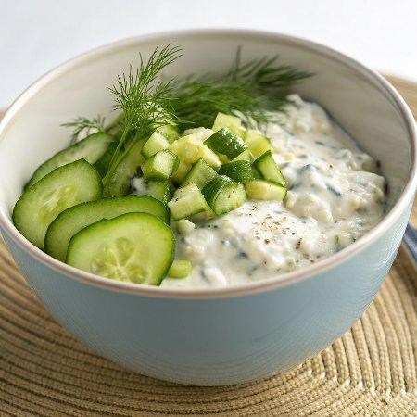

INGREDIENTS  - 1 cup (240ml) whole Greek yogurt, (preferably Fage (important see notes*))  - 10 oz. English cucumber**, (peeled if desired, seeded)  - 1 1/2 Tbsp chopped fresh dill***  - 1 garlic clove, (finely minced (1 tsp))  - 1 Tbsp extra virgin olive oil  - 1 Tbsp fresh lemon juice  - Sea salt (or table salt, to taste and optionally black pepper) | PREP  COOK  1. Peel cucumber if desired (it adds a faint texture and a will lightly tint the dip, but this is optional to peel). Slice cucumber in half throught the length and use a spoon to remove seeds.  2. Chop cucumber into chunks, then add to a food processor.**** Pulse until cucumber is almost finely chopped.  3. Remove blade from food processor, then press cucumber against the sides of the processor bowl to remove some of the excess liquid, reserve liquid (proceed to step 1 in notes if you aren't using a very thick Greek yogurt).  4. Add yogurt, cucumber, dill, garlic, olive oil and lemon juice to a medium mixing bowl. Season with salt, and pepper if using, to taste.  5. Stir mixture until well blended. If you find it's a little thick for your liking you can pour in some of the reserved cucumber juice from the food processor.  6. If serving over warm food (like salmon, chicken, steak, gyro or cooked veggies) let rest at room temperature about 30 minutes. Store in refrigerator.  PLATING

