CRAB DIP (BEST MARYLAND STYLE)  COOK TIME: 25 min  SOURCE:  #seafood #comfort-food #party-food | 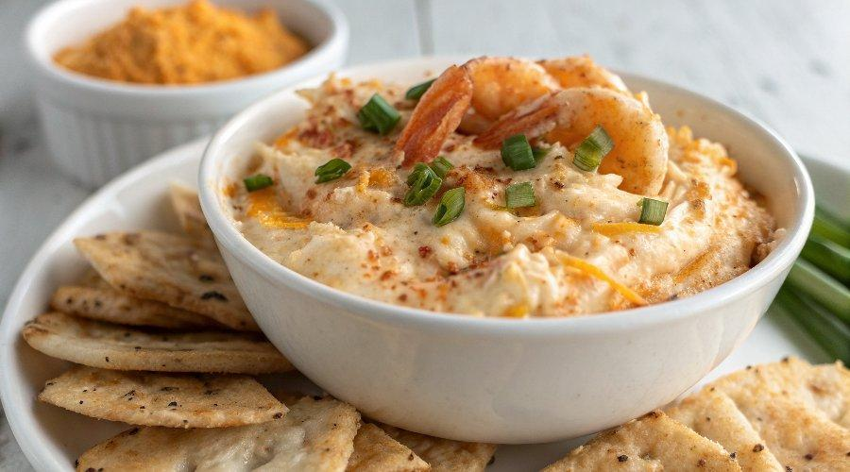

INGREDIENTS  - 8 oz (226 g) full-fat brick cream cheese, softened to room temperature  - 1/4 cup (60 g) mayonnaise  - 1/2 cup (120 g) sour cream  - 1 and 1/4 cups (155 g) shredded cheddar cheese, divided  - 1/2 tsp ground mustard  - 1 tsp lemon juice  - 1 and 3/4 tsp Old Bay seasoning*  - 2 tsp Worcestershire sauce  - 1 lb fresh lump crab meat*  - optional: 2 dashes of hot sauce (or to taste) | PREP  COOK  1. Preheat oven to 375°F (191°C).  2. In a large mixing bowl using a handheld or stand mixer fitted with a paddle attachment, beat the cream cheese on medium-high speed until smooth and creamy, about 1 minute.  3. Add the mayonnaise, sour cream, 1 cup (240ml) cheddar cheese, ground mustard, lemon juice, Old Bay seasoning, Worcestershire sauce, and hot sauce (if using). Beat on medium-high speed until combined. Using a spoon or silicone spatula, gently fold in the lump crab meat. If you used hot sauce, taste, then add more hot sauce if desired.  4. Transfer to a 9-inch (or slightly larger) baking pan, pie dish, or oven-safe skillet. Sprinkle with remaining 1/4 cup of cheddar cheese.  5. Bake for 25 minutes or until hot and bubbly around the edges.  6. Serve warm.  7. Cover and store leftovers in the refrigerator for up to 5 days. Reheat in the microwave or in a 350°F (177°C) oven until warmed throughout.  PLATING

