PEANUT CHICKPEA RICE BOWL  COOK TIME: 30 min  SOURCE:  #quick #healthy #comfort-food | 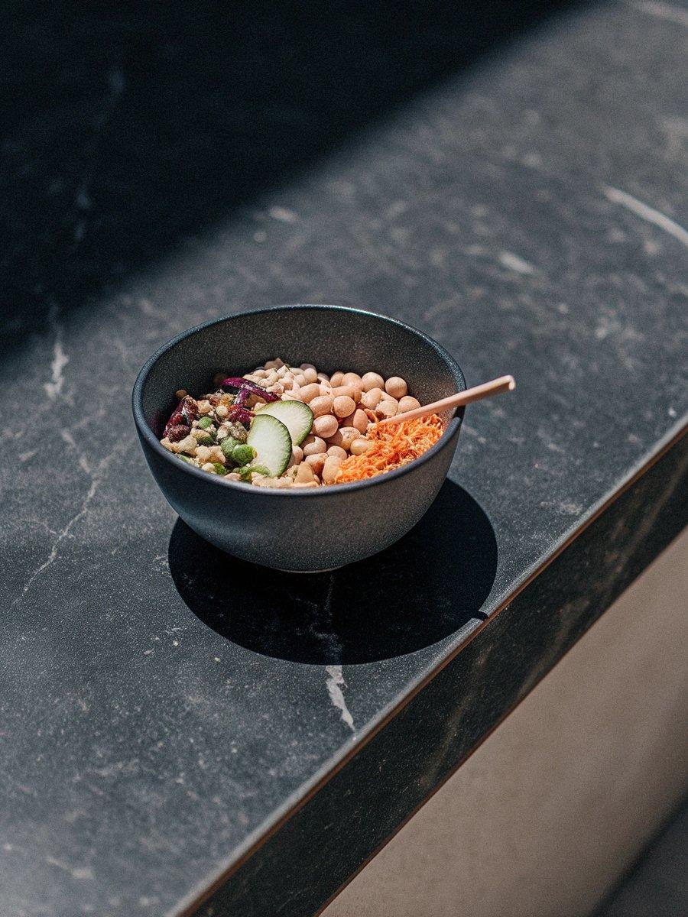

INGREDIENTS  - 2 x 400 g cans of chickpeas drained and dried using kitchen paper  - small bunch of coriander finely chopped (save some extra whole leaves to serve, optional)  - 1 carrot cut into matchsticks (no need to peel)  - 1/2 cucumber seeds scooped out and cut into half-moons  - 1/2 red cabbage finely shredded  - 400 g brown rice cooked  - sesame seeds crispy onions or sliced red chilli, to serve  - 4 tbsp crunchy peanut butter  - 3 tsp reduced salt soy sauce  - 1 lime juiced  - 1 tbsp chilli oil (optional)  - 1/2 tsp maple syrup or mild flavoured honey | PREP  COOK  1. Heat the oven or air fryer to 200C/190C fan/gas  6. Make the dressing by mixing all of the ingredients together and season lightly. Pour the chickpeas onto a lined baking sheet and toss with half the dressing. Bake for 20-25 mins until crispy and golden. Leave to cool for 5 mins.  2. Mix the remaining dressing with enough water to make a pourable consistency. Mix the chopped coriander, carrot, cucumber and red cabbage together in a small bowl, and season lightly.  3. Split the rice between bowls, top with the veg mix and crispy chickpeas, then scatter over the coriander leaves, sesame seeds, crispy onions and sliced chilli, if you like.  PLATING

