CHINESE TOFU SHEET STIR-FRY (千张肉丝)  COOK TIME: 10 min  SOURCE:  #stir-fry #pork #quick | 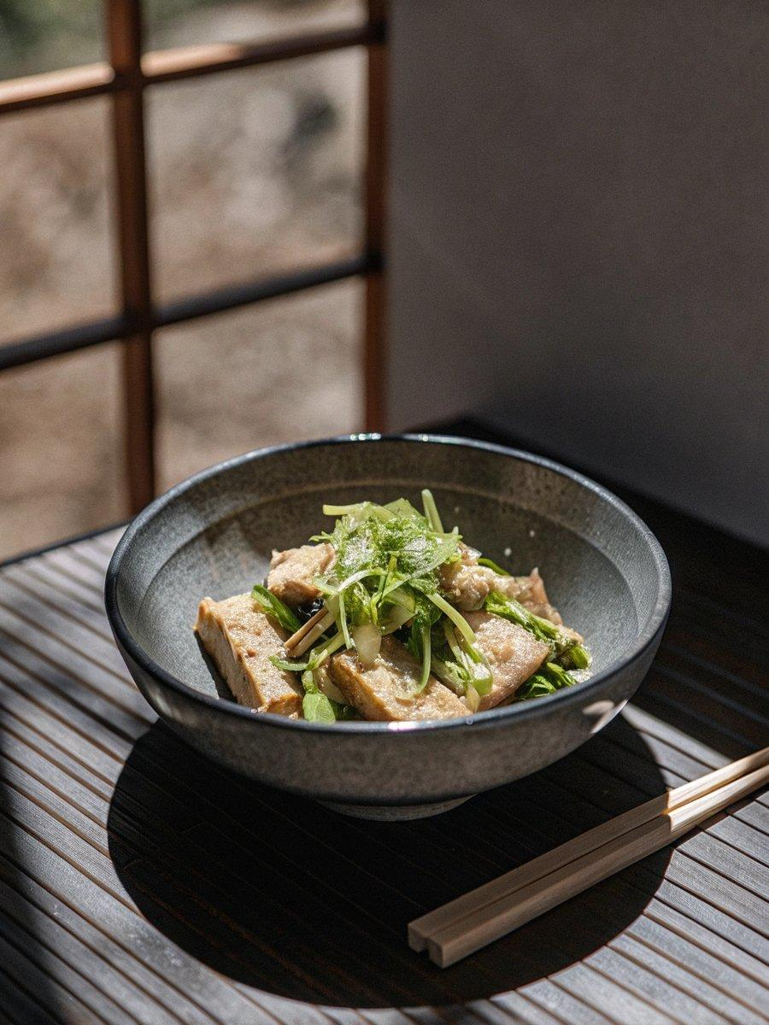

INGREDIENTS  - 6 oz boneless pork shoulder or loin (or chicken thigh/breast meat, about 180 g)  - 1 tsp Shaoxing wine  - 1 tsp light soy sauce  - 1/4 tsp sesame oil  - 1 tsp water  - 1/2 tsp cornstarch  - 1/8 tsp white pepper  - 2 1/2 tbsp vegetable oil  - 2 slices ginger (julienned)  - 2 cloves garlic (roughly chopped)  - 1/4 tsp dark soy sauce  - 8-10 oz tofu sheets (250 g, cut into bite-sized pieces)  - 4 long hot green peppers (cut into bite-sized strips)  - 1 tbsp Shaoxing wine  - 1 tbsp light soy sauce  - 1/4 tsp sugar  - 1/2 tsp sesame oil  - 1/4 tsp white pepper | PREP  COOK  1. Julienne the meat to ¼-inch thickness. Mix the meat together with the marinade ingredients until there is no visible standing liquid. Marinate for 15-20 minutes while you prepare everything else.  2. Preheat the wok over high heat. When the wok starts smoking, add 2½ tablespoons oil. Immediately reduce the heat to medium, and cook the ginger for 30 seconds. Add the garlic and cook for another 15 seconds.  3. Next, add in the pork, turn the heat back up, and cook for 1-2 minutes until the pork has cooked through. Resist the urge to stir too much, so the pork can brown lightly.  4. Reduce the heat to medium, and add ¼ teaspoon dark soy sauce. Stir-fry everything well. Add the tofu sheets and peppers. Stir fry everything together, and season with 1 tablespoon Shaoxing wine, 1 tablespoon light soy sauce, ¼ teaspoon sugar, ½ teaspoon sesame oil, and ¼ teaspoon white pepper powder.  5. Turn up the heat, and stir-fry everything together for 1-2 minutes. The dish is complete when the peppers are just tender, but still slightly crisp. As you stir-fry, keep an eye on the sauce: if the food is too dry and beginning to stick or burn, add a tablespoon of water. If you end up with an excess of visible sauce, keep stir-frying with the heat on high until everything is just lightly coated in sauce.  PLATING

