WHITE CHOCOLATE STRAWBERRY CUPCAKES  COOK TIME: 20 min  SOURCE:  #sweet #baking #chocolate | 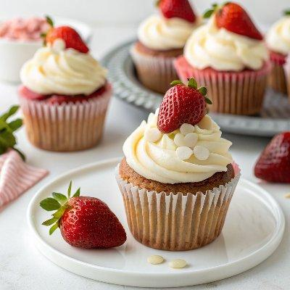

INGREDIENTS  - 1 and 3/4 cups (207 g) cake flour (spooned & leveled)  - 1 tsp baking powder  - 1/4 tsp baking soda  - 1/4 tsp salt  - 1/2 cup (8 Tbsp; 113 g) unsalted butter, softened to room temperature  - 1 cup (200 g) granulated sugar  - 3 large egg whites, at room temperature  - 1/4 cup (60 g) sour cream or plain yogurt, at room temperature  - 1 and 1/2 tsp pure vanilla extract  - 1/3 cup (80 ml) whole milk, at room temperature  - 1/4 cup reduced strawberry puree (see note)*  - 1 cup (about 25 g) freeze-dried strawberries*  - 1 cup (16 Tbsp; 226 g) unsalted butter, softened to room temperature  - 2 cup (480ml)s (240 g) confectioners’ sugar  - 6 oz (170 g) white chocolate, melted and slightly cooled (see note)*  - 1/4 cup (60 ml) heavy cream, half-and-half, or milk, at room temperature  - 1 tsp pure vanilla extract  - 1/8 tsp salt  - optional: fresh strawberries coated with 2 oz melted white chocolate | PREP  COOK  1. Make the reduced strawberry puree  2. and allow it to cool completely. See Note for instruction.  3. Preheat the oven to 350°F (177°C). Line a 12-cup muffin pan with cupcake liners. Line a second pan with 2 or 3 liners—this recipe makes 14–15 cup (3600ml)cakes. Set aside.  4. Whisk the cake flour, baking powder, baking soda, and salt together. Set aside.  5. Using a handheld or stand mixer fitted with a whisk attachment, beat the butter and sugar together on high speed until smooth and creamed, about 2 minutes. Scrape down the sides and up the bottom of the bowl with a rubber spatula as needed. Beat in the egg whites on high speed until combined, about 2 minutes. Beat in the sour cream and vanilla extract. Scrape down the sides and up the bottom of the bowl as needed. With the mixer on low speed, add the dry ingredients until just incorporated. With the mixer still running on low, slowly pour and mix in the milk *just* until combined. Do not overmix. Whisk in 1/4 cup of reduced strawberry puree, making sure there are no lumps at the bottom of the bowl. Batter will be slightly thick.  6. Pour/spoon the batter into the liners. Fill only 2/3 full to avoid spilling over the sides when baking. Bake for 20–22 minutes, or until a toothpick inserted in the center comes out clean. For about 35 mini cupcakes, bake for about 11–13 minutes, same oven temperature.  7. Allow the cupcakes to cool completely before frosting.  8. When the cupcakes are nearly cool, melt the white chocolate for the frosting: Place chopped white chocolate in a microwave-safe bowl (I usually use a glass liquid measuring cup), and microwave in 20-second increments, stirring after every 20 seconds until completely smooth. Set it aside to cool at room temperature for 20 minutes. (Be sure the melted white chocolate has cooled for 20 minutes, so it’s still melted but not scorching hot, which would melt the butter.)  9. Make the frosting:  1  0. Using a blender or food processor, process the freeze-dried strawberries into a powdery crumb. You should have around 1/2 cup. Set aside. In a medium bowl using a handheld or stand mixer fitted with a paddle attachment, beat the butter on medium speed for 1 minute. Switch the mixer to low speed and slowly add the confectioners’ sugar and strawberry powder. Stir the cooled white chocolate so that it is smooth, and then add it to the butter/sugar mixture. Switch the mixer to medium speed and beat for 2 minutes until combined and creamy. Add the cream, vanilla extract, and salt. Beat for 1 minute until combined. Taste. Add 1 more Tablespoon of heavy cream/milk if needed to thin out, if desired. Add another pinch of salt if frosting is too sweet.  1  1. Frost cooled cupcakes and serve. I used Wilton 8B piping tip and nestled a white chocolate-covered strawberry in the center.  1  2. Cover and store leftovers in the refrigerator for up to 5 days.  PLATING

