CHEDDAR BACON PORTOBELLO MUSHROOM BURGER.  COOK TIME: 10 min  SOURCE:  #comfort-food #grilled #quick | 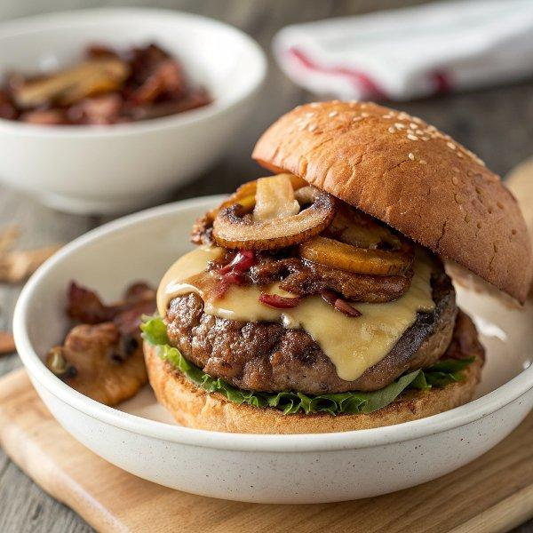

INGREDIENTS  - 1/4 cup balsamic vinegar  - 2 tbsp low sodium soy sauce  - 2 tbsp Dijon mustard  - 1/3 cup olive oil  - crushed red pepper flakes (to taste)  - pepper (to taste)  - 4 portobella mushroom caps (stems removed)  - 4 slices sharp cheddar or harvarti cheese (omit if vegan)  - 4 brioche burger buns (toasted (use gluten free if needed)  - 4 tbsp fig preserves  - 8 slices cooked bacon (omit if vegeterain/vegan)  - 4 fried eggs  - arugula or lettuce (tomato)  - 1/4 cup ketchup  - 1/4 of your favorite BBQ sauce  - 1 tsp smoked paprika | PREP  COOK  1. In a large gallon size zip top bag, combine the balsamic vinegar, soy sauce, mustard, olive oil, crushed red pepper flakes and pepper. Add the mushroom caps and toss to coat. Let the mushrooms marinate 30 minutes to 1 hour.  2. Preheat an outside grill or grill pan to high. Place the mushrooms on the grill and grill until lightly charred, about 3-5 minutes. Flip and grill an additional 3-5 minutes. During the last minute add the cheese.  3. Spread each toasted bottom bun with fig preserves. Add you mushroom burgers, bacon and eggs. Top as desired with tomatoes + arugula. Spread each top bun with ketchup (see below) and then add it to your burger. Eat!  4. Smoky Ketchup  5. Combine everything in a small bowl. Serve with your burgers and fries!  PLATING

