SAUSAGE AND VEGETABLE SKILLET  COOK TIME: 15 min  SOURCE:  #quick #comfort-food #one-pan | 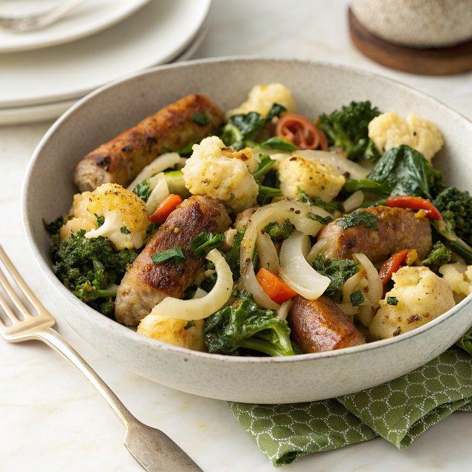

INGREDIENTS  - 1 Tbsp cooking oil ($0.04)  - 1 lb. Italian sausage ($5.99)  - 1/2 lb. frozen cauliflower florets ($1.00)  - 1/2 lb. frozen peppers and onions ($1.00)  - 1/4 lb. frozen kale ($0.83)  - 1/2 tsp seasoning salt or seasoning blend (or to taste) ($0.05) | PREP  COOK  1. Add the cooking oil and sausage to a skillet. Cook the sausage over medium heat until brown and crispy.  2. Add the cauliflower, peppers and onions, and kale to the skillet with the sausage. Continue to stir and cook until the vegetables are heated through.  3. Add a liberal amount (or to taste) of your favorite seasoning salt or seasoning blend and stir to combine. Serve hot.  PLATING

