CREAMY LEMON TOFU  COOK TIME: 10 min  SOURCE:  #creamy #tofu #lemon #quick #comfort-food | 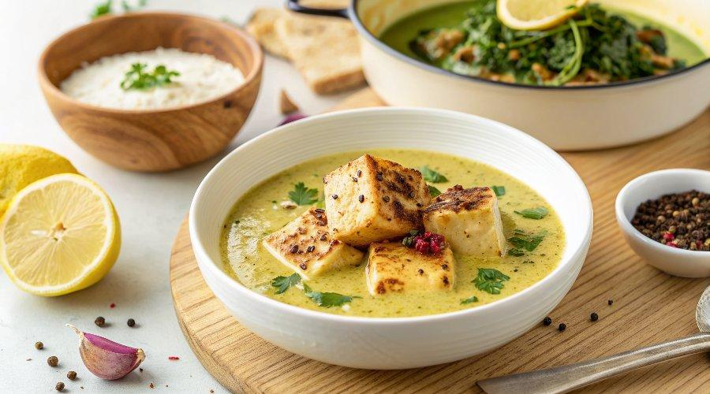

INGREDIENTS  - 1 block extra-firm tofu (14.5-16 oz)  - 1/4 tsp salt  - black pepper  - 1/4 cup cornstarch  - 3 tbsp olive oil  - 2 cloves garlic  - 3/4 cup vegetable broth  - 3/4 cup full fat coconut milk  - 3-4 tbsp fresh lemon juice (about 2 lemons)  - salt, to taste  - 1 tbsp cornstarch + 2 tbsp water, optional for thickening sauce  - 8 oz pasta, cooked according to package  - OR cooked rice, mashed potatoes  - chopped fresh parsley, optional | PREP  COOK  1. If serving with pasta, get the water boiling in a large pot. When it's boiling, cook the pasta according to package instructions, then drain and set aside. I do this at the same time the tofu is frying.  2. Slice the tofu into 1/2-inch (5cm) thick rectangles. Cut the block in half, then into about 3 slices each. You could also slice the tofu into triangles or smaller cubes, if desired. Pat the tofu dry with paper towels and lay evenly on a large cutting board or piece of parchment paper.  3. Sprinkle each side with salt, a few shakes black pepper, then sprinkle on cornstarch, rubbing it in with your fingers, on both sides.  4. In a large non-stick or cast iron skillet over medium heat, warm 2 tablespoons of the olive oil. Add the tofu and cook for about 2-3 minutes until crispy, then carefully use a spatula to get under the tofu and flip it to the other side. To prevent sticking, do not move it once you place it on the pan, wait 2-3 minutes before touching it. Also, use a quality pan that is not prone to sticking, and a thin spatula to get under the tofu. Cook for 2-3 minutes on the other side, then remove from the pan and place on a plate nearby.  5. To the pan, add the last tablespoon of olive oil. Add the garlic and cook for about 30 seconds. Now pour in the broth, coconut milk and lemon juice. Bring to a simmer and stir for about 3 minutes. Taste, and add more salt as desired (I added another 1/2 teaspoon).  6. In a small bowl, whisk together 1 tablespoon of cornstarch with 2 tablespoons water, then add to the sauce and stir to thicken. You could skip this for a thinner sauce, but I liked it a bit thicker.  7. Return the tofu to the sauce. There will be a lot of extra sauce, which is good because it's delicious mixed into pasta (or rice), with a few pieces of tofu on top.  8. Serve over cooked pasta, rice or even mashed potatoes. Spoon additional sauce over the top and sprinkle with parsley if desired. I like to have a green vegetable on the side, such as roasted asparagus, roasted brussels sprouts or cooked kale. Enjoy!  PLATING

