SLOW-ROASTED LAMB WITH CURRY LEAF MARINADE  COOK TIME: 4 hrs 30 mins  SOURCE: Unknown  #lamb #Australian #roast | 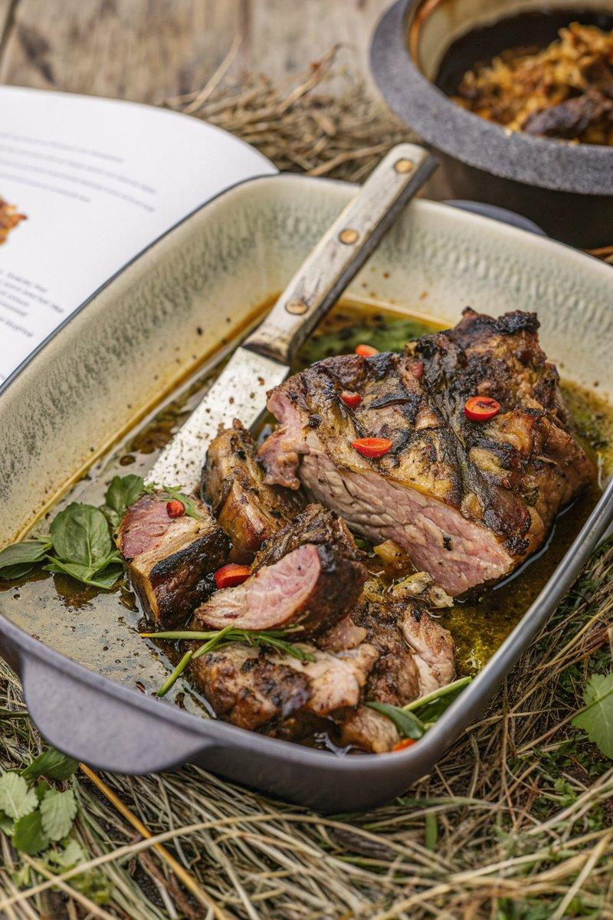

INGREDIENTS  - {'group': 'Main', 'item': '1.8-2kg lamb leg, bone in'}  - {'group': 'Marinade', 'item': '100g curry leaf'}  - {'group': 'Marinade', 'item': '2 heads garlic, peeled'}  - {'group': 'Marinade', 'item': '5 scud chillies'}  - {'group': 'Marinade', 'item': '5 tbsp mustard seeds'}  - {'group': 'Marinade', 'item': '3 tbsp coriander seeds'}  - {'group': 'Main', 'item': '1/4 cup vegetable oil'}  - {'group': 'Main', 'item': '2 potatoes, scrubbed and sliced thickly'}  - {'group': 'Main', 'item': '3 onions, peeled and sliced thickly'}  - {'group': 'Main', 'item': '1/2 can beer'} | PREP  In a large mortar and pestle, roughly pound the curry leaf, garlic, chillies, mustard seeds, and coriander seeds. Rub this mixture all over the lamb leg, cover, and refrigerate overnight.  COOK  Preheat the oven to 160°C (140°C (285°F (141°C)) fan-forced). Heat the vegetable oil in a large, heavy-based pan and sear the lamb on all sides until golden brown. Arrange the potato and onion slices at the bottom of a roasting pan, placing the lamb leg on top. Pour the beer into the bottom of the pan. Roast the lamb in the oven, basting every 15 minutes with the pan juices, for 4 hours 30 minutes to 5 hours, until the meat is tender and falling off the bone.  PLATING  Remove the lamb from the oven and let it rest, loosely covered with foil, for 10 minutes. Slice the lamb and serve it on a tray or return it to the roasting pan with the potatoes and onions.

NOTES:
For best results, marinate the lamb overnight to allow the flavours to fully develop.

