CLASSIC TUNA MELT SANDWICH  COOK TIME: 10 mins  SOURCE: Unknown  #tuna #American #sandwich | 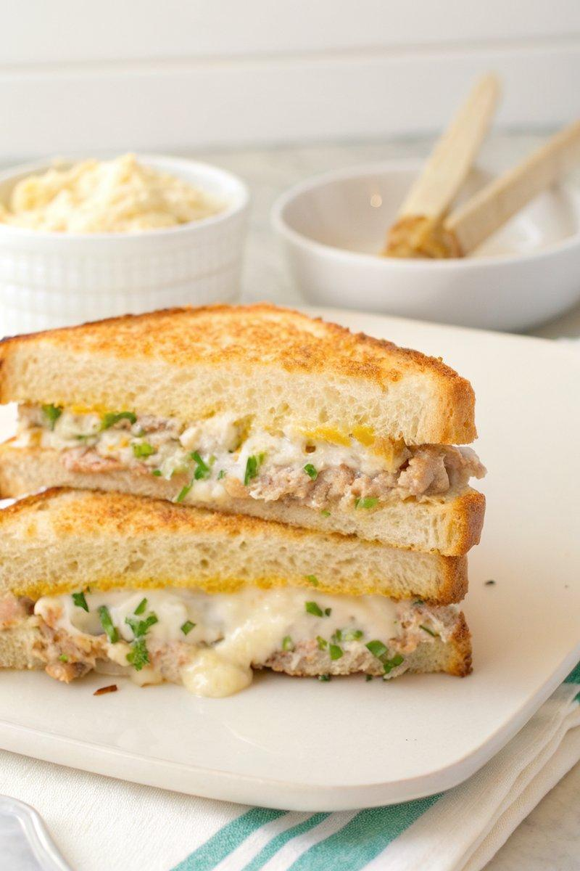

INGREDIENTS  - {'group': 'Main', 'item': '140g can solid white tuna in olive oil, drained'}  - {'group': 'Main', 'item': '58g mayonnaise'}  - {'group': 'Main', 'item': '10g Dijon mustard'}  - {'group': 'Main', 'item': '1 medium rib celery, finely chopped'}  - {'group': 'Main', 'item': '1 shallot, finely chopped'}  - {'group': 'Main', 'item': '1 sprig dill, finely chopped'}  - {'group': 'Main', 'item': '1 dill pickle, finely chopped'}  - {'group': 'Main', 'item': 'Kosher salt and freshly cracked black pepper, to taste'}  - {'group': 'Main', 'item': '35g unsalted butter'}  - {'group': 'Main', 'item': '2 slices thick-cut country bread'}  - {'group': 'Main', 'item': '4 slices Swiss or Gouda cheese'}  - {'group': 'Garnish', 'item': 'Thinly sliced chives (optional)'} | PREP  In a medium bowl, shred the tuna with a fork until fine. Add mayonnaise, Dijon mustard, celery, shallot, dill, and dill pickle. Season with salt and pepper, mixing until well combined.  COOK  Heat butter in a 25cm (10-inch) pan over medium heat until melted and bubbling. Add bread slices and toast for 2-3 mins until golden brown on one side. Flip and toast the other side. Top each slice with half of the tuna mixture and layer with 2 slices of cheese. Broil on high or use a blow torch to melt the cheese completely.  PLATING  Top with thinly sliced chives if desired. Close the sandwich, slice diagonally, and serve immediately.

NOTES:
For a variation, try using Gouda cheese for a different flavour profile. Serve with potato chips or a green salad for a complete meal.

