CLASSIC BACON, LETTUCE, AND TOMATO SANDWICH  COOK TIME: 20 mins  SOURCE: Unknown  #bacon #American #sandwich | 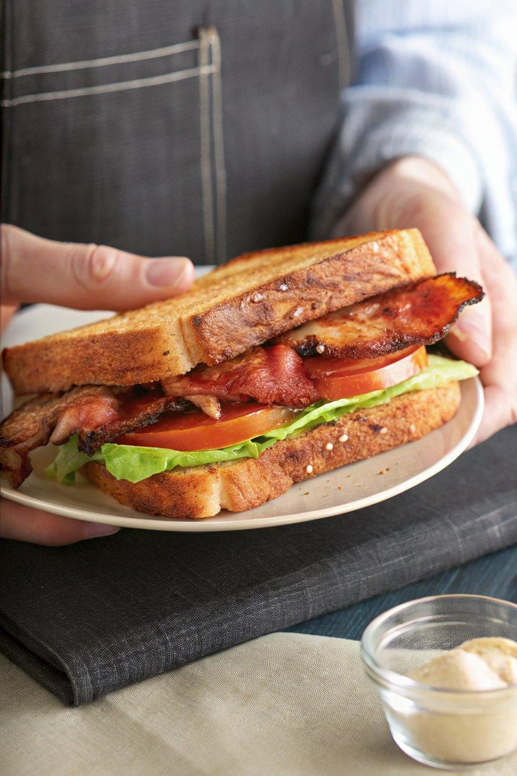

INGREDIENTS  - {'group': 'Main', 'item': '16 slices thick-cut bacon'}  - {'group': 'Main', 'item': '8-12 slices ripe tomato'}  - {'group': 'Seasoning', 'item': 'Kosher salt and freshly cracked black pepper'}  - {'group': 'Sauce', 'item': '6 tbsp mayonnaise'}  - {'group': 'Sauce', 'item': '6 tbsp Dijon mustard'}  - {'group': 'Main', 'item': '8 slices sourdough bread, toasted'}  - {'group': 'Main', 'item': '8 leaves butter lettuce'} | PREP  Mix the mayonnaise and Dijon mustard in a small bowl. Season the tomato slices with salt and pepper on both sides.  COOK  Preheat the oven to 220°C (425°F (220°C)). Arrange the bacon slices on a foil-lined baking sheet and place in the cold oven. Roast for 20 minutes or until the bacon is browned and crispy. Drain on paper towels.  PLATING  Spread the Dijon-mayo sauce on each slice of toasted sourdough. Layer butter lettuce, seasoned tomato slices, and crispy bacon on half of the bread slices. Top with the remaining bread slices, cut diagonally, and serve immediately.

NOTES:
For enhanced flavour, toast the sourdough bread in a pan with butter instead of using a toaster.

