CLASSIC GRILLED CHEESE SANDWICH  COOK TIME: 10 mins  SOURCE: Unknown  #cheese #American #pan-fry | 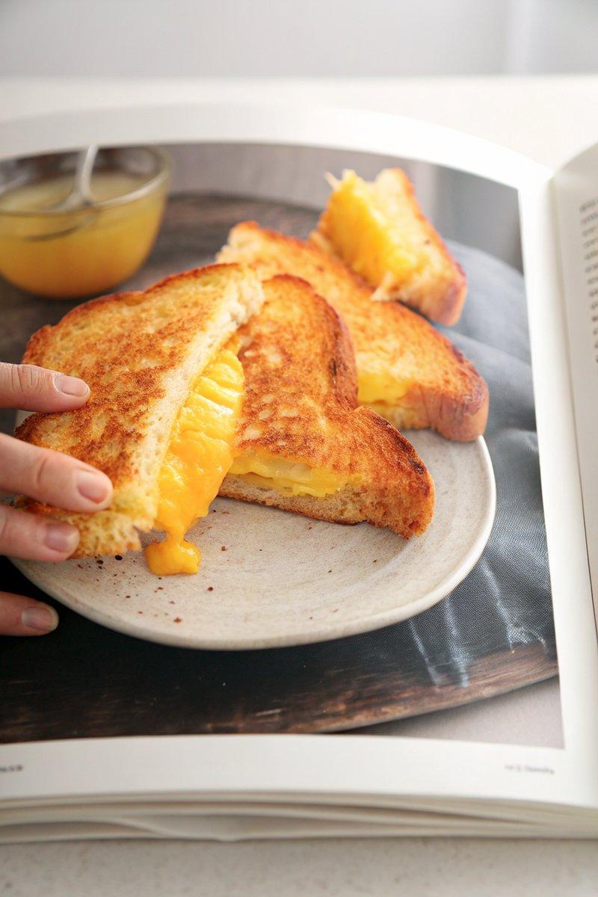

INGREDIENTS  - {'group': 'Main', 'item': '4 tbsp salted butter, softened'}  - {'group': 'Main', 'item': '4 slices of cheese'} | PREP  Spread 1 tbsp of softened salted butter on one side of each bread slice.  COOK  Heat a pan over medium heat. Place two slices of bread, buttered side down, in the pan. Top each with two slices of cheese, then cover with the remaining bread slices, buttered side up. Cook until the bread is golden brown and the cheese has melted, about 3-4 mins per side.  PLATING  Cut the sandwiches in half and serve immediately, ideally with a side of tomato soup.

NOTES:
For best results, use a non-stick pan to ensure an even golden crust.

