GRILLED STEAK SANDWICHES WITH GRUYERE  COOK TIME: 10 mins  SOURCE: Unknown  #beef #American #grilled | 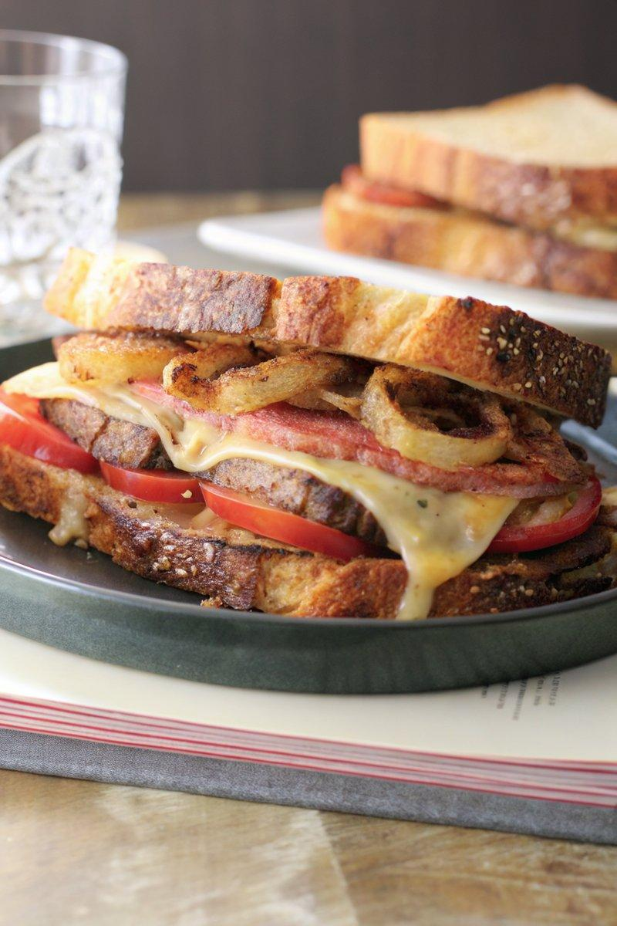

INGREDIENTS  - {'group': 'Main', 'item': '2 large steaks (450g each), cooked and sliced 1.25cm thick'}  - {'group': 'Main', 'item': '1 large sweet onion, cut into 1.25cm rings'}  - {'group': 'Main', 'item': '2 large tomatoes, sliced into 1.25cm slices'}  - {'group': 'Main', 'item': '8 slices sourdough bread, toasted'}  - {'group': 'Main', 'item': '8 slices Gruyere cheese'}  - {'group': 'Sauce', 'item': '120ml mayonnaise'}  - {'group': 'Sauce', 'item': '45g whole-grain mustard'}  - {'group': 'Sauce', 'item': '2 cloves garlic, grated'}  - {'group': 'Sauce', 'item': '10g freshly grated horseradish (optional)'}  - {'group': 'Seasoning', 'item': 'Kosher salt and freshly cracked black pepper'} | PREP  In a small bowl, mix mayonnaise, mustard, garlic, and horseradish. Season with salt and pepper. Slice the onion and tomatoes, and season the tomato slices with salt and pepper.  COOK  Heat oil in a skillet over medium-high heat. Sear onion rings for 2-3 mins per side until deeply caramelized. Preheat the broiler. On a baking sheet, assemble sandwiches with sauce, tomatoes, steak, onions, and cheese. Broil until cheese melts.  PLATING  Top each sandwich with the remaining slice of sauced bread. Serve immediately, sliced in half or whole.

NOTES:
For best results, use a high-quality steak and adjust the seasoning to taste. The horseradish adds a nice kick but is optional.

